Complete HIL Flow

**Step 1:** Raise Loan application through Unqork and see offers

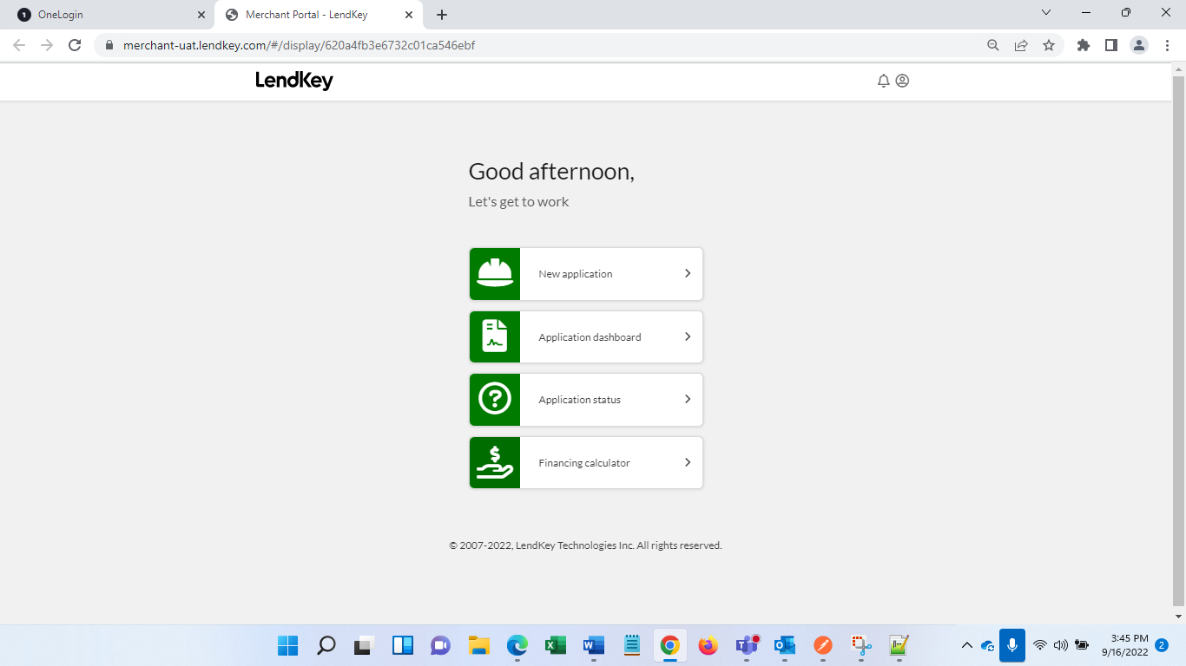 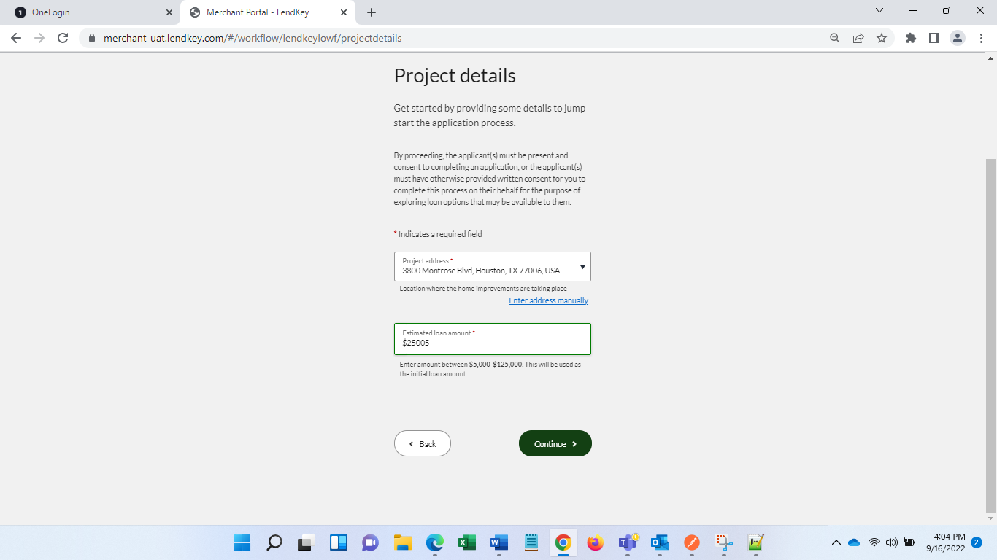 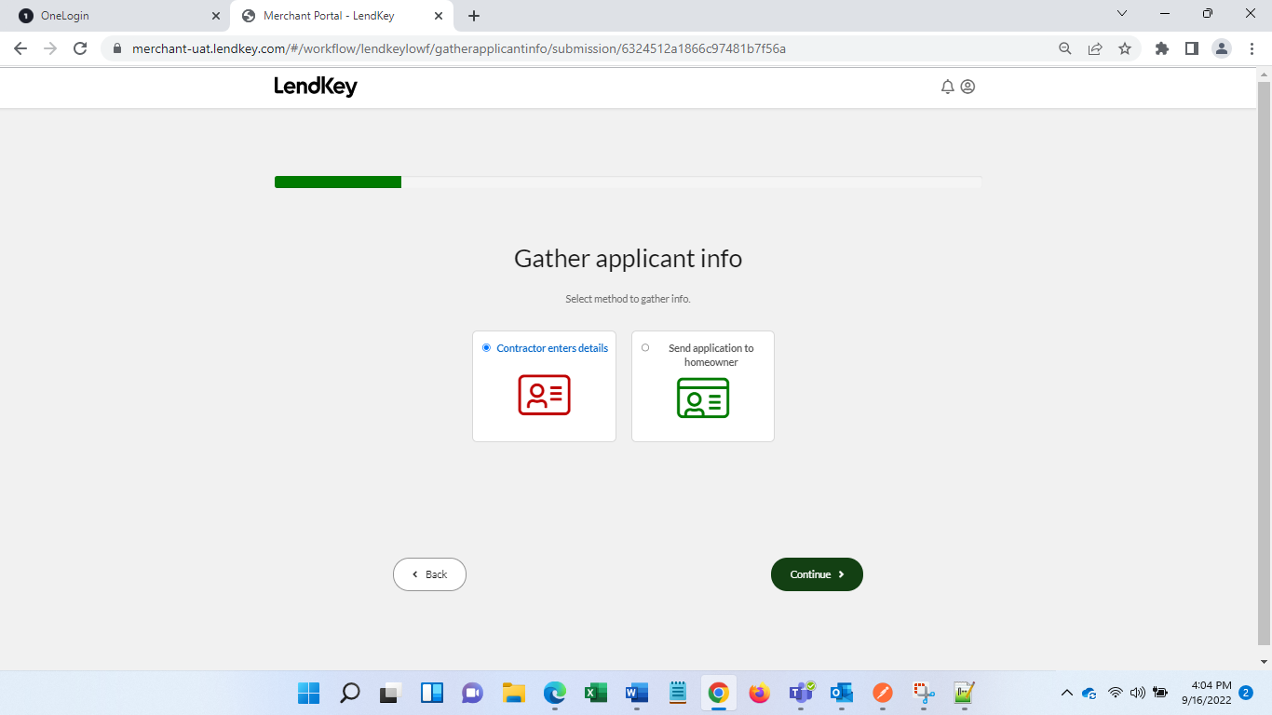 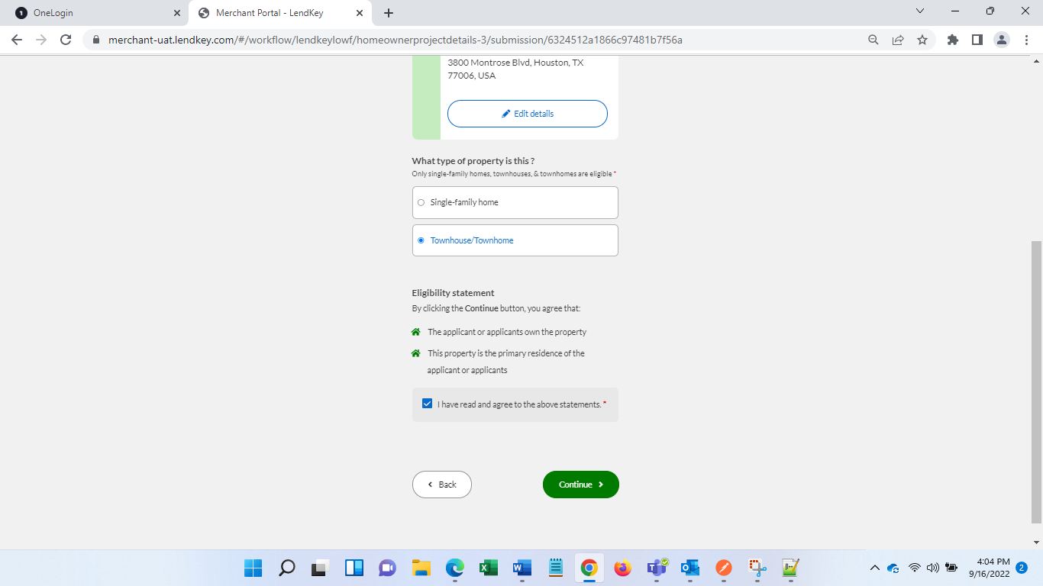 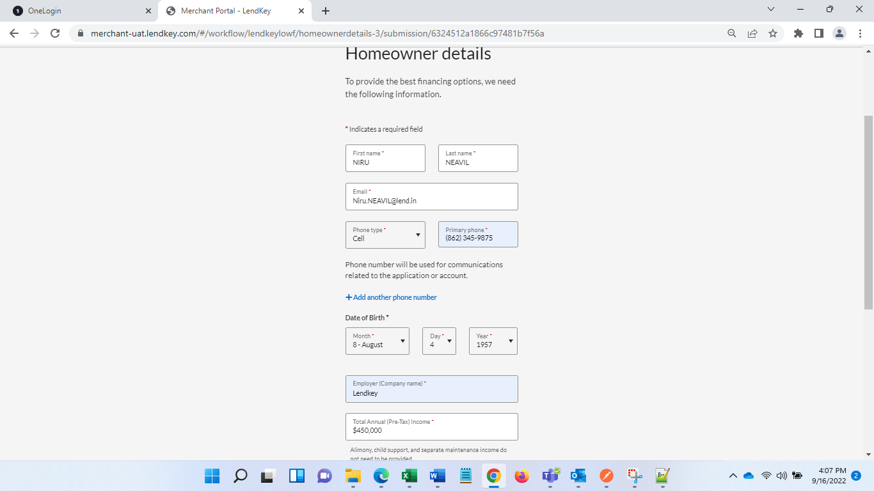 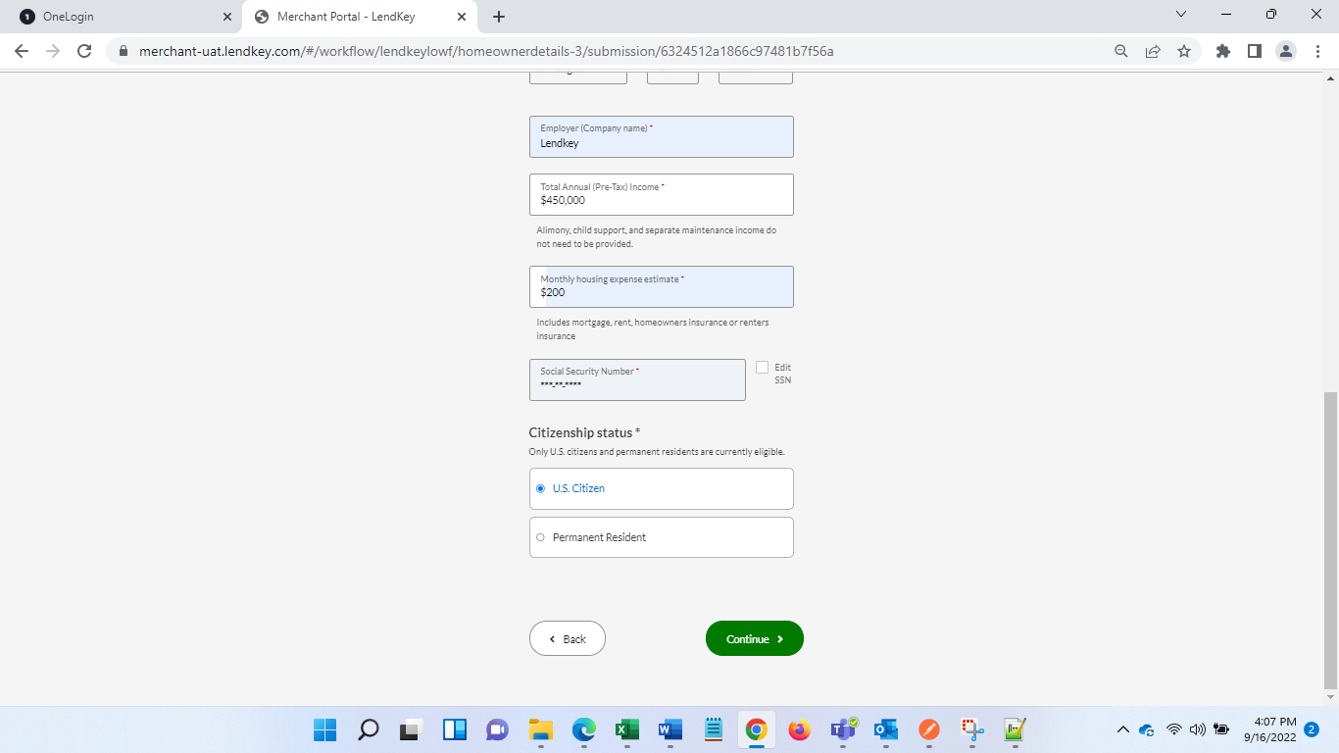 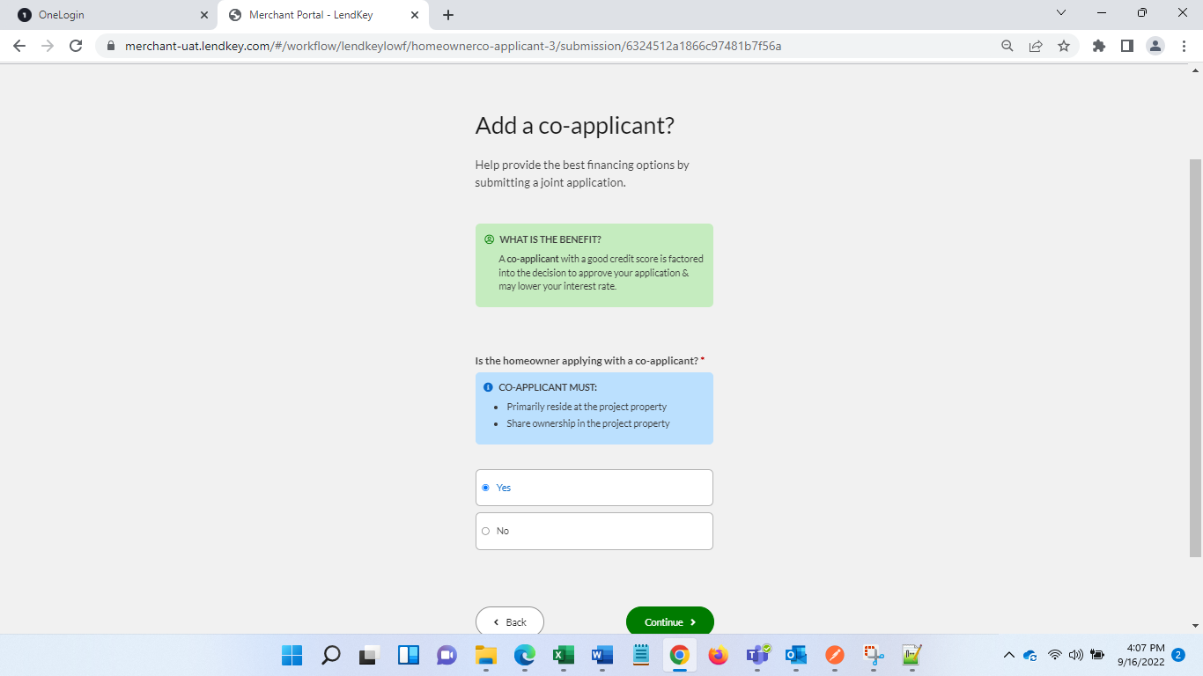 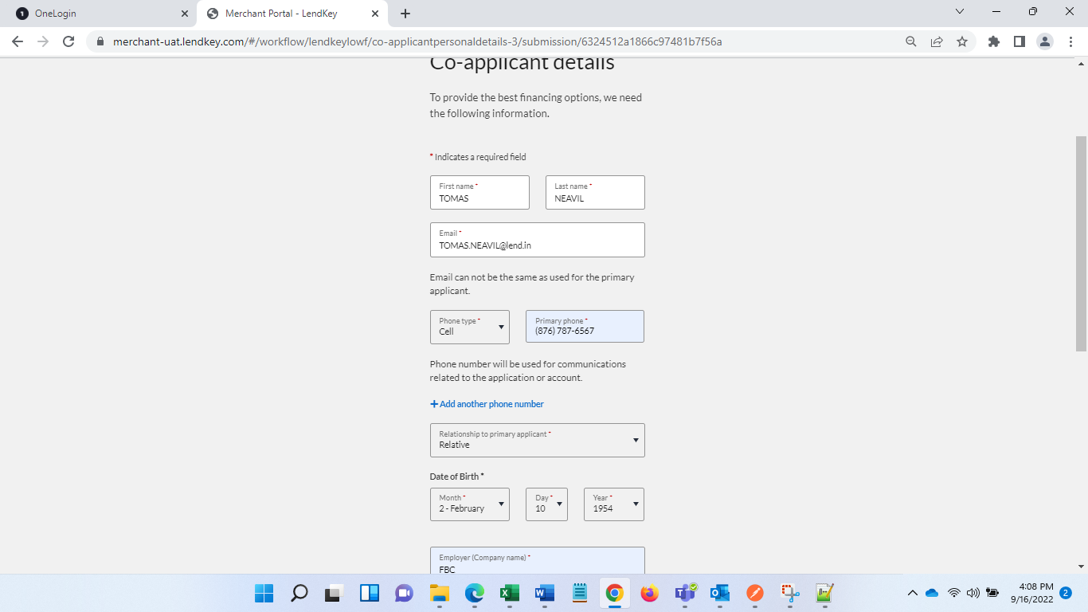 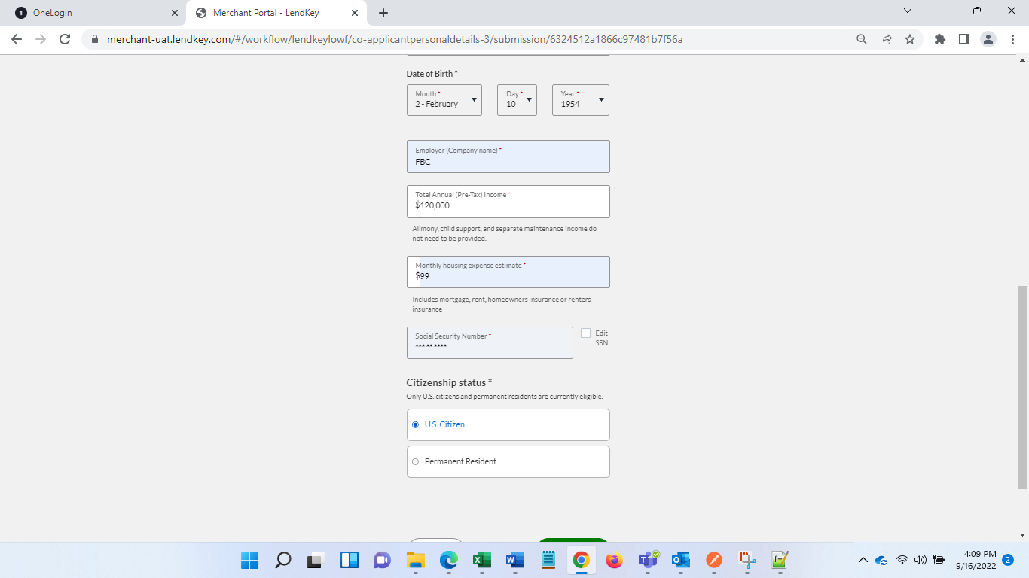 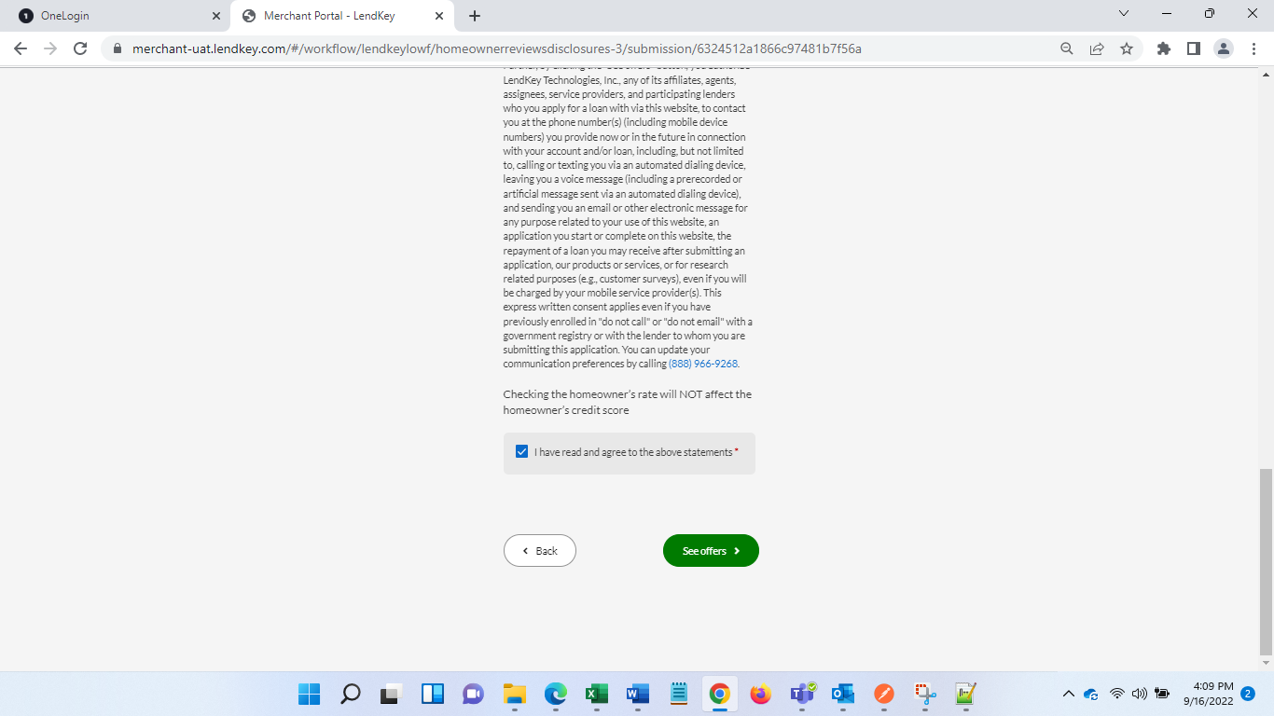

**Step 2:** Select offer and continue to GH

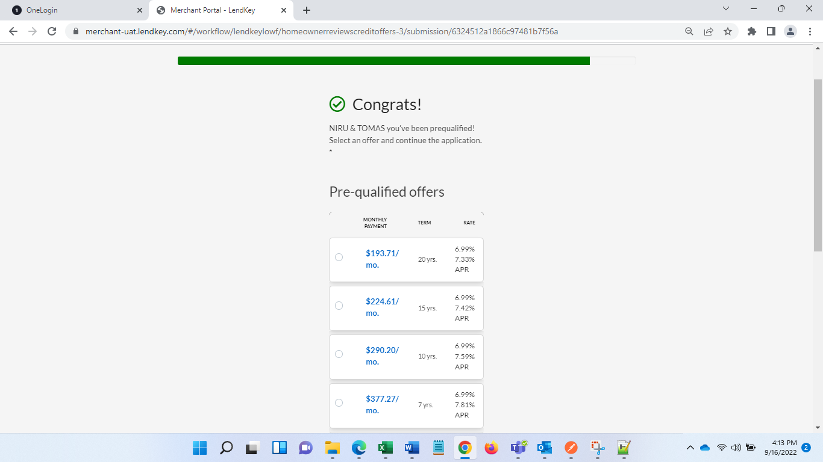 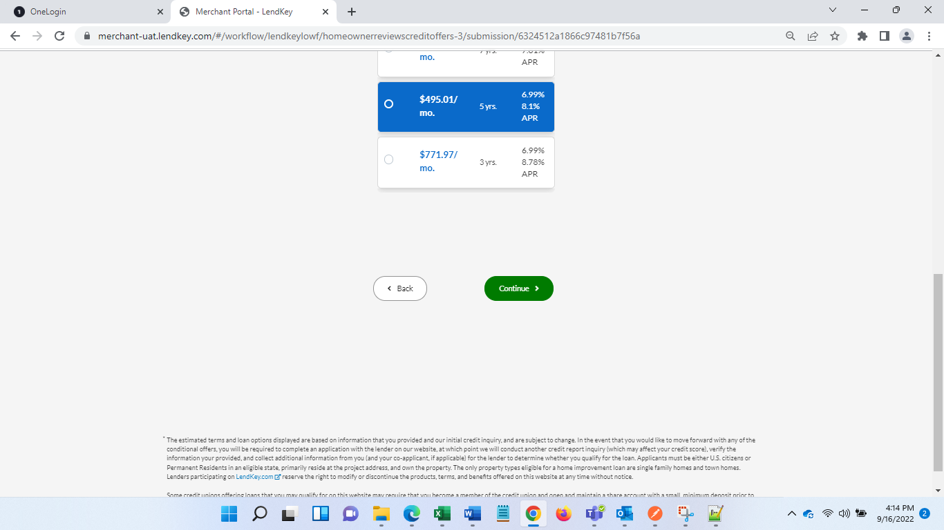 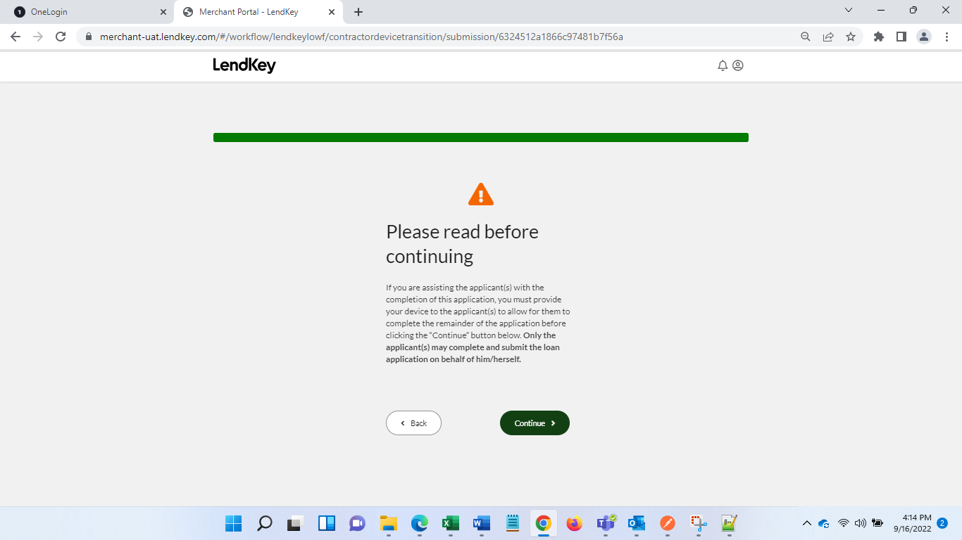

Step 3: Enter all the mandatory values on GH and hit submit

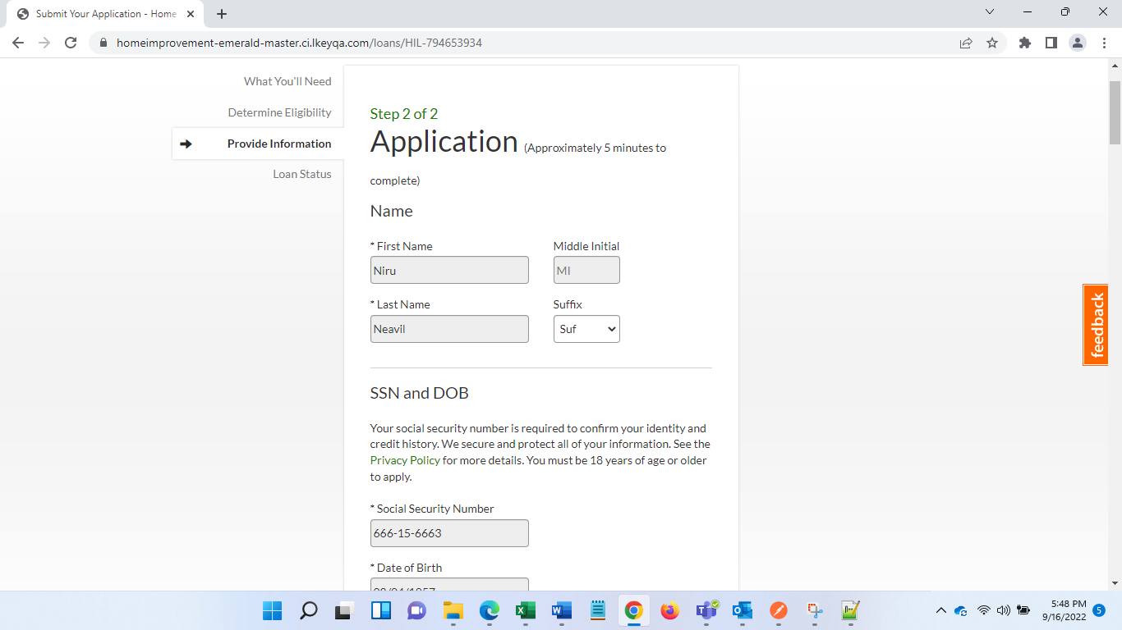 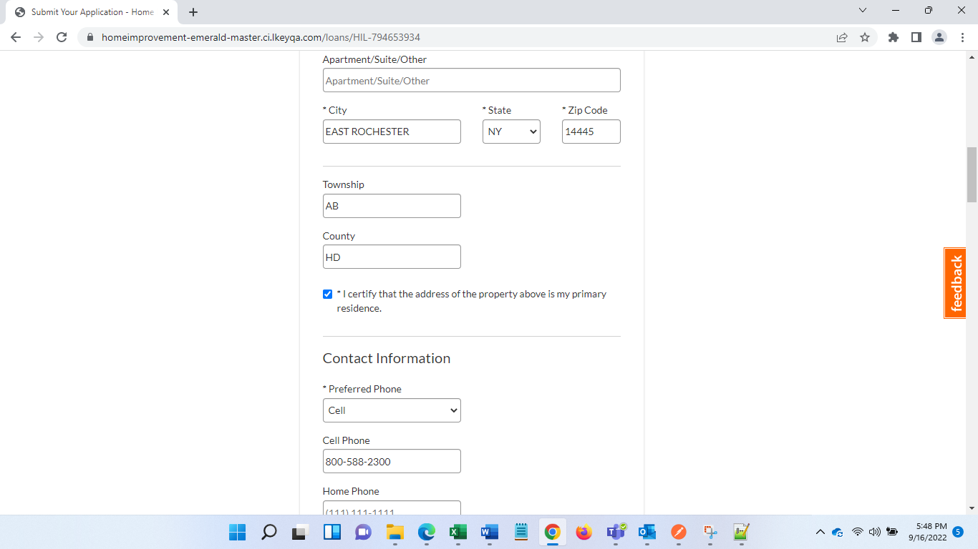 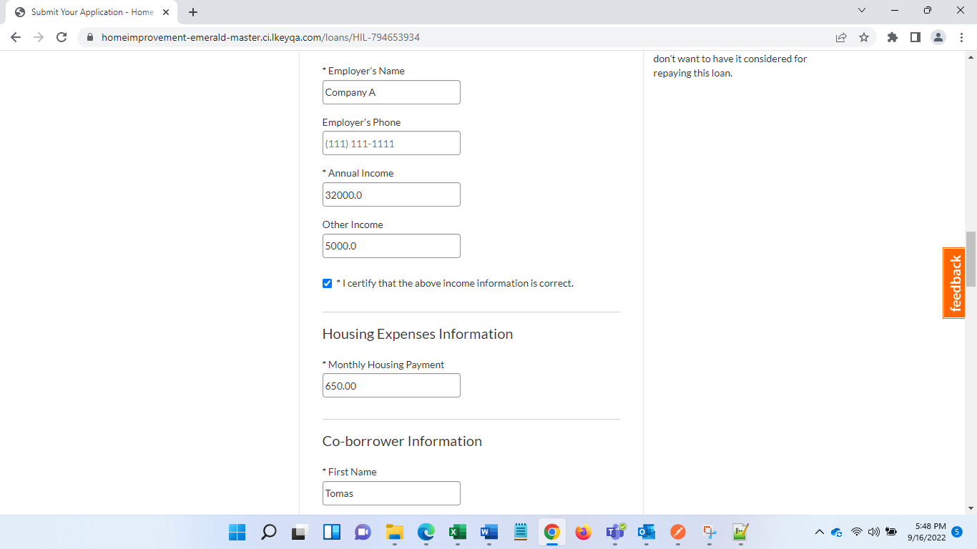 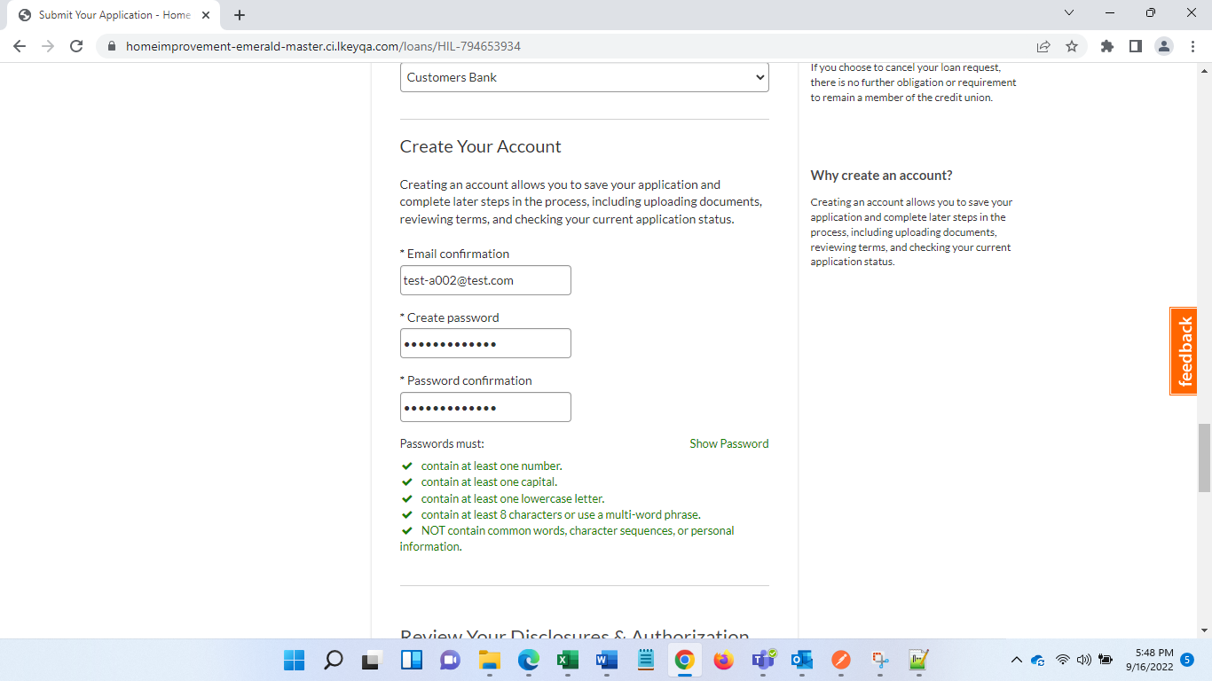 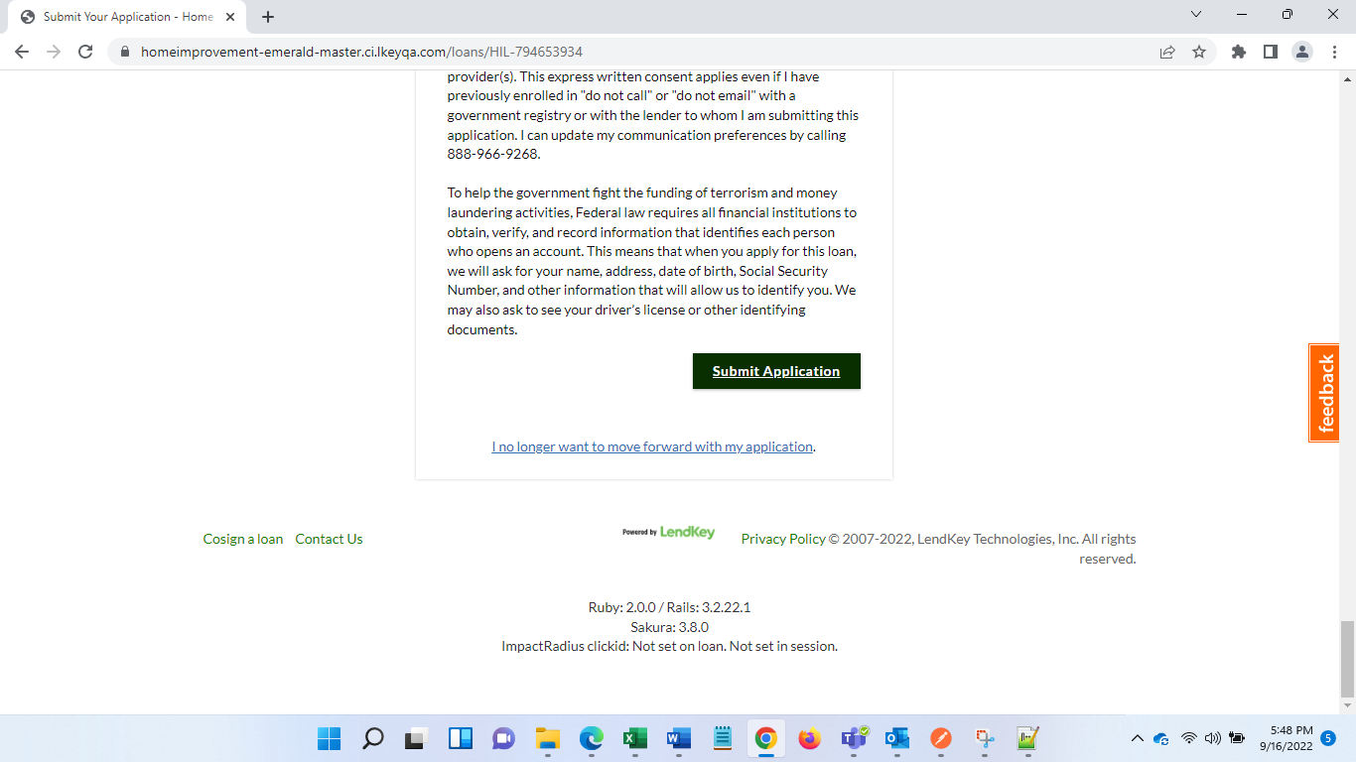

If you face issue with SSN and email , then go to Ops admin and there change SSN of already submitted applications.

Select admin>> Borrower>> Search with SSN>> Click Loan number >> change SSN from Borrower or coborrwer tab

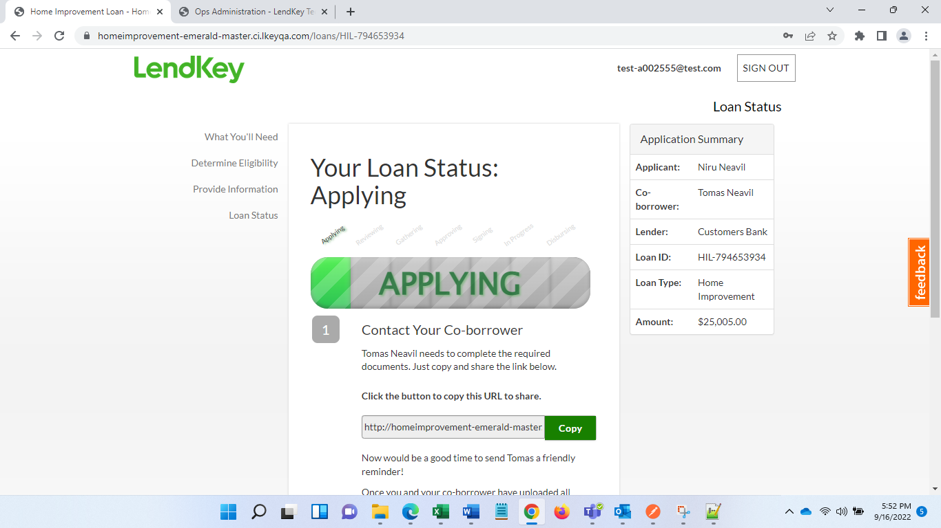

Step 4: Contact co-borrower

Copy link and open it in another browser, fill details and complete co-borrower application

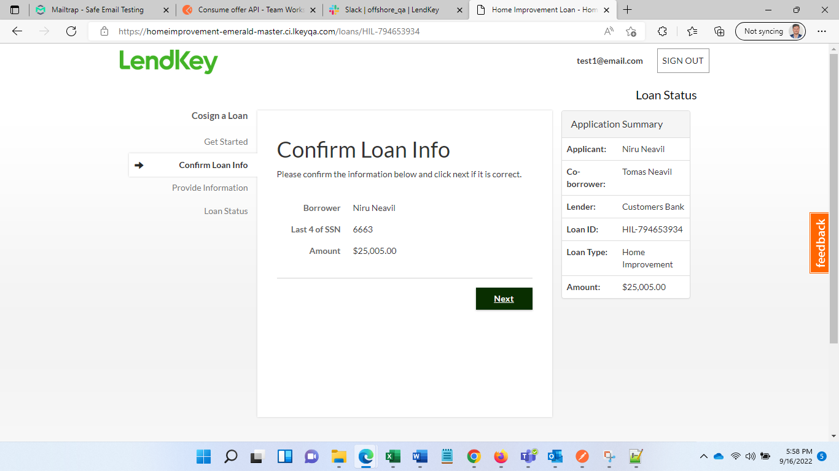 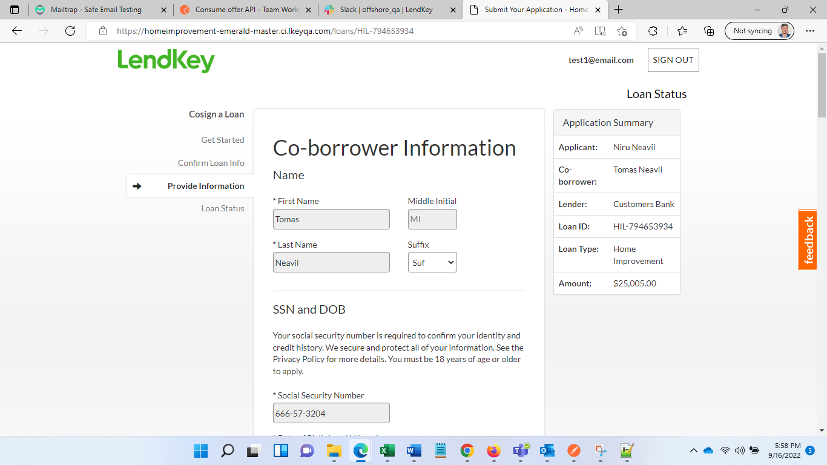 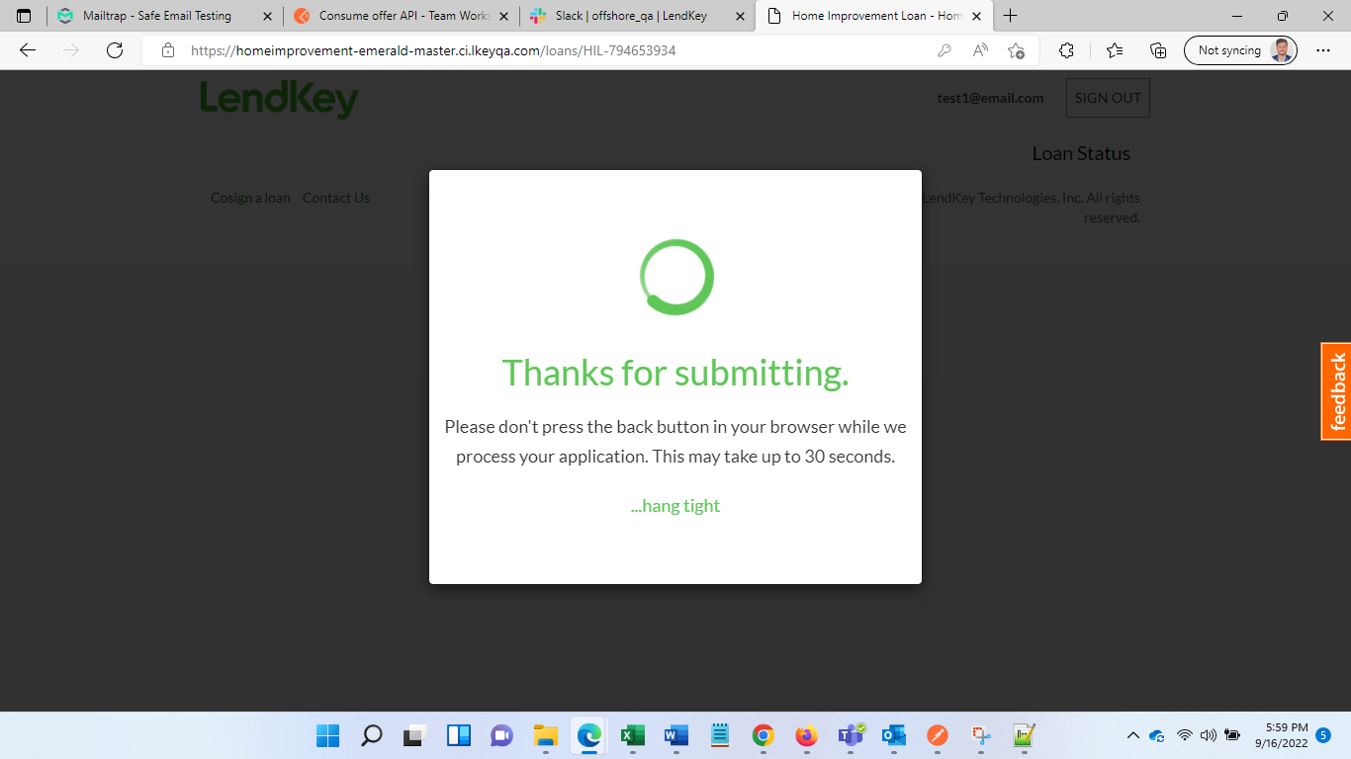 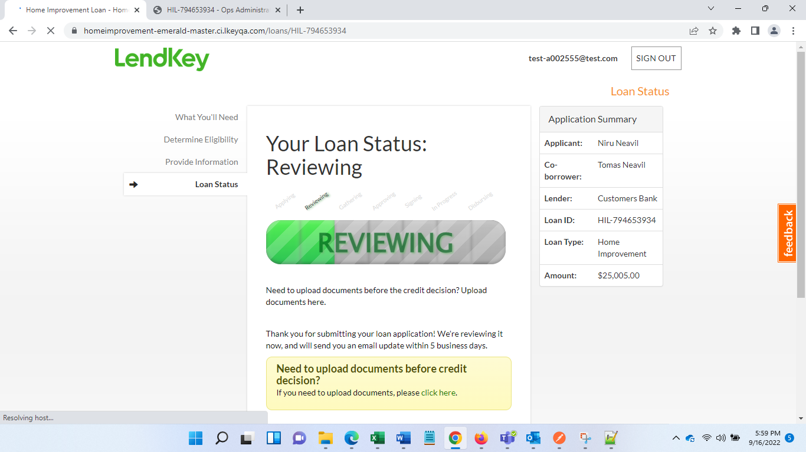

You will see reviewing status once you click submit application for co-borrower. Once hard pull is completed status will be changed to Gathering

. 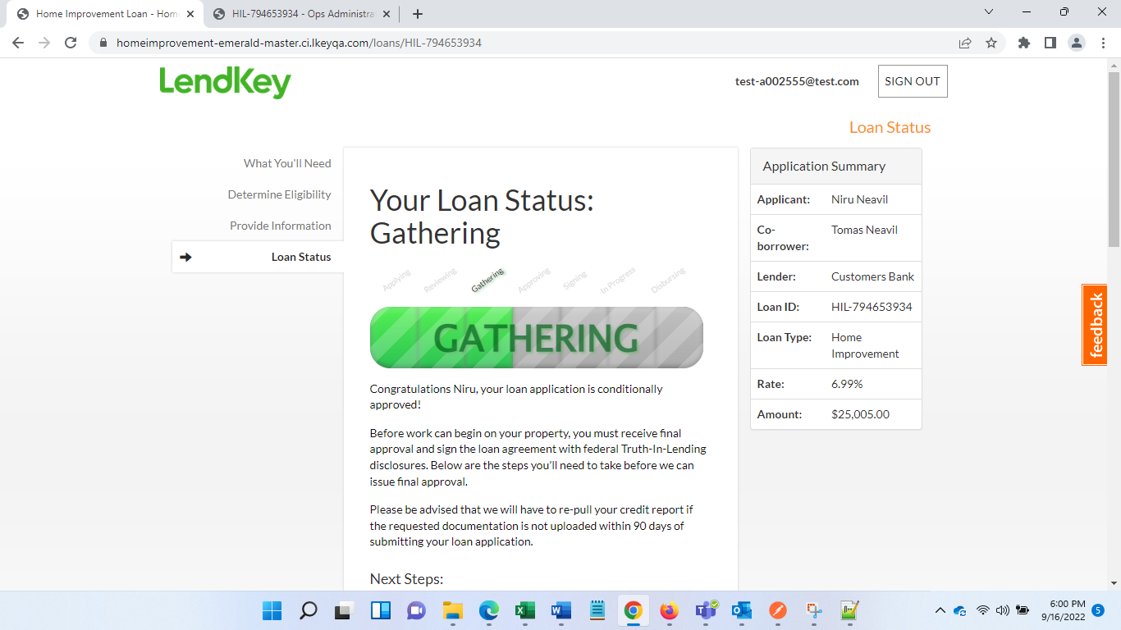

Step 5: See application blocker on Ops admin page or GH borrower application and proceed to solve blockers.

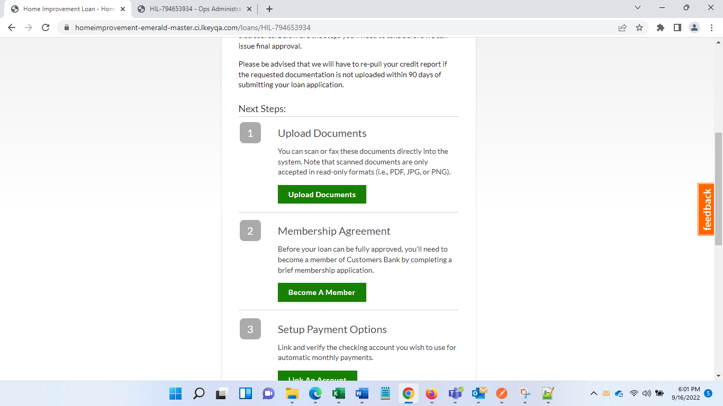s 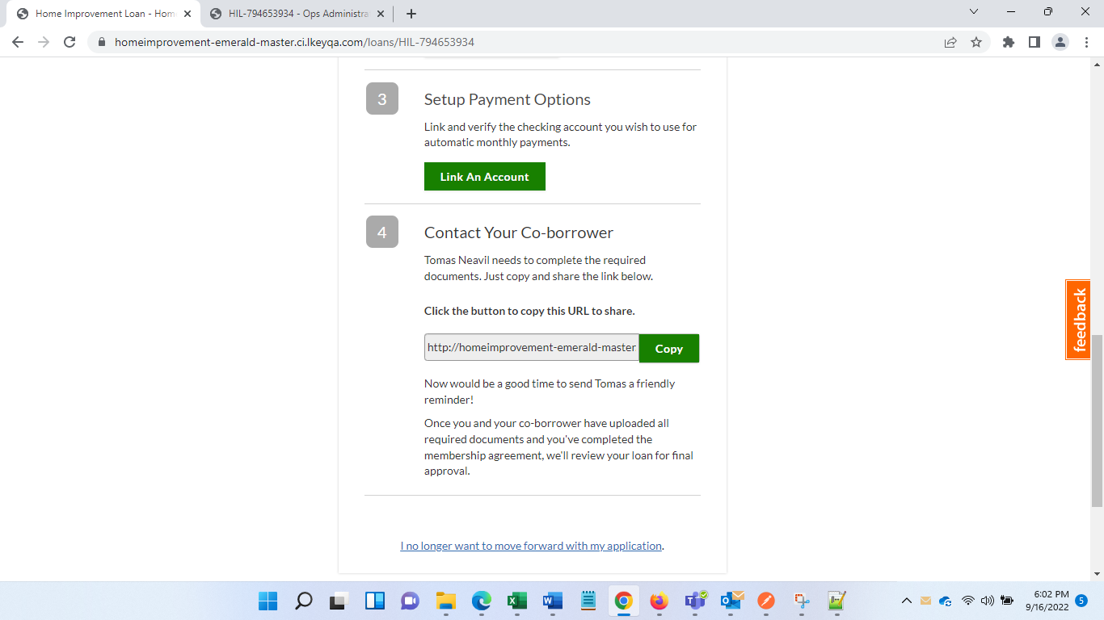 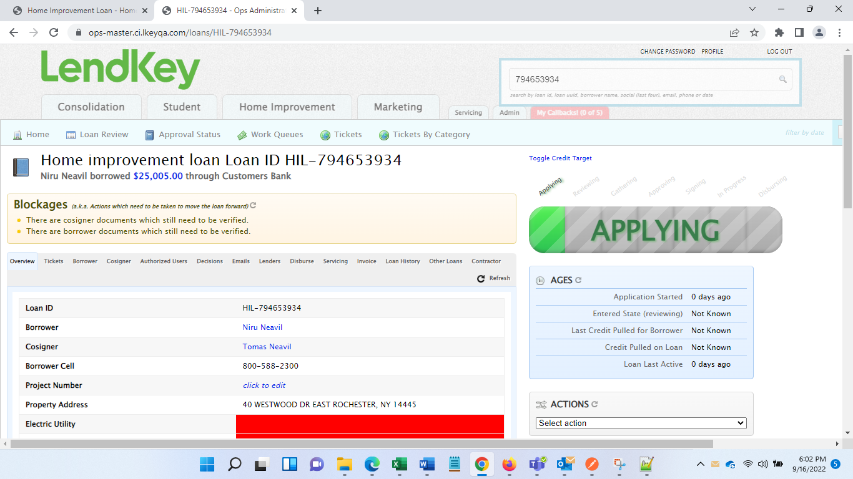

Upload documents for both and then verify those documents on Ops admin

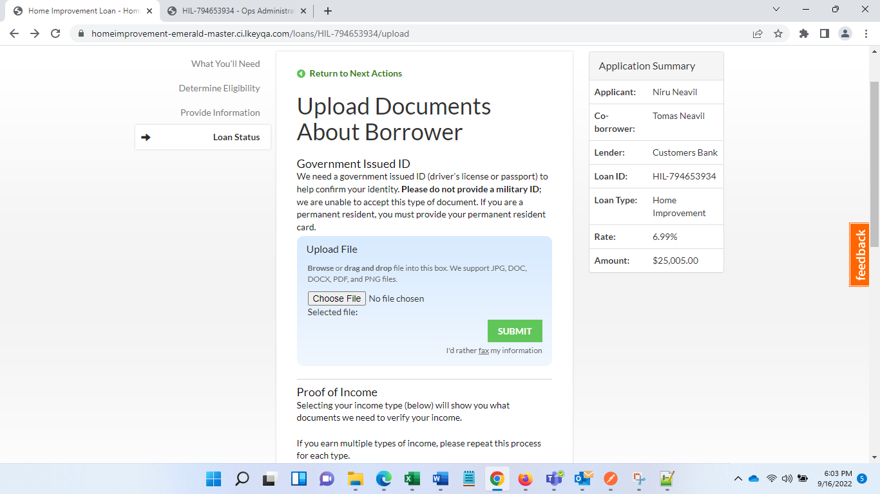

Submit co-borrowers documents

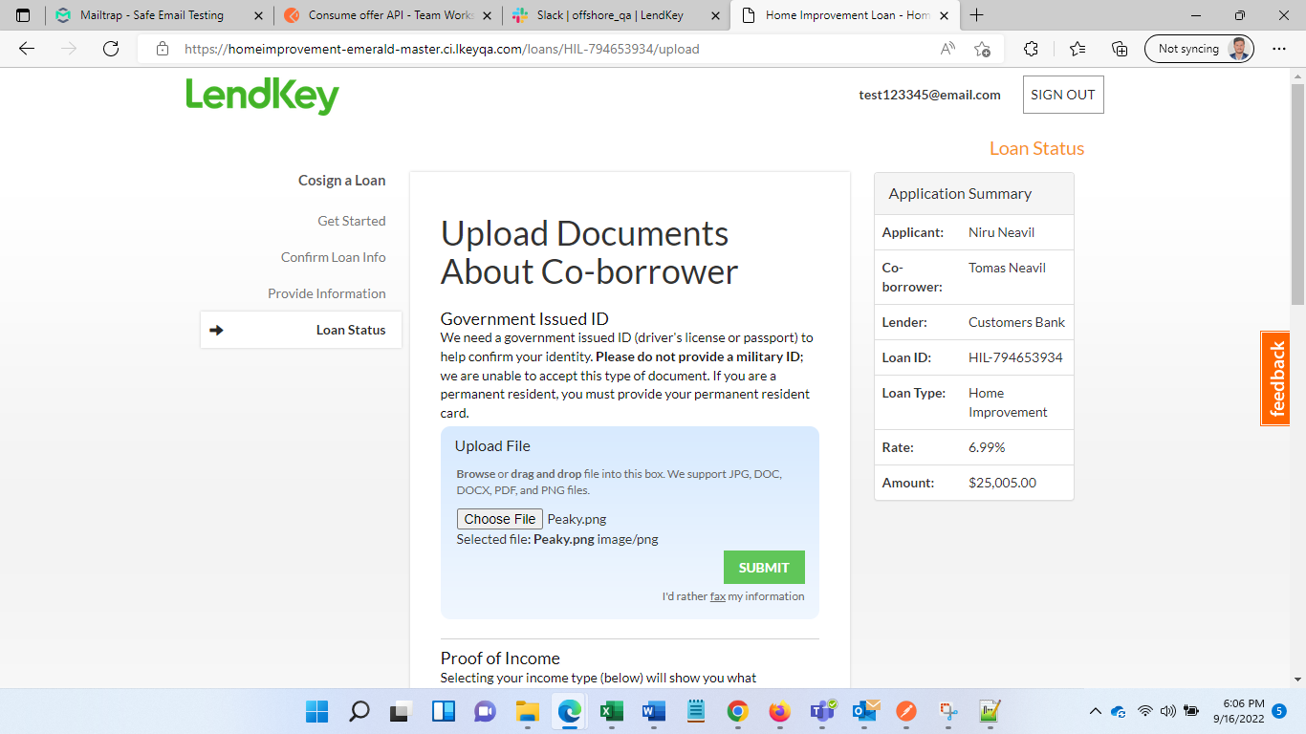 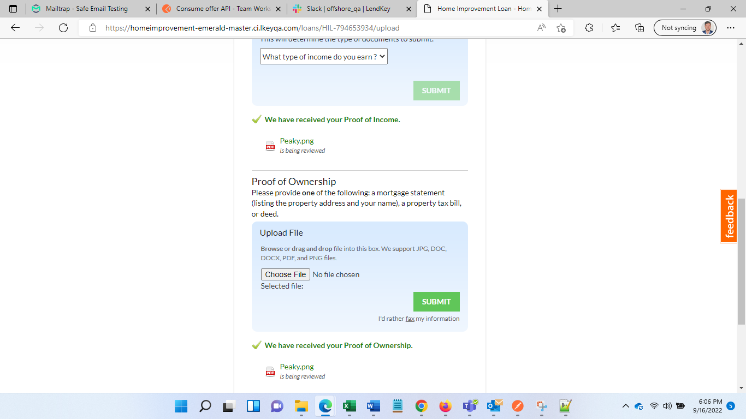

Verify documents for both

Go to loan Jacket on Ops-admin>> Documents >> then Verfiy each document

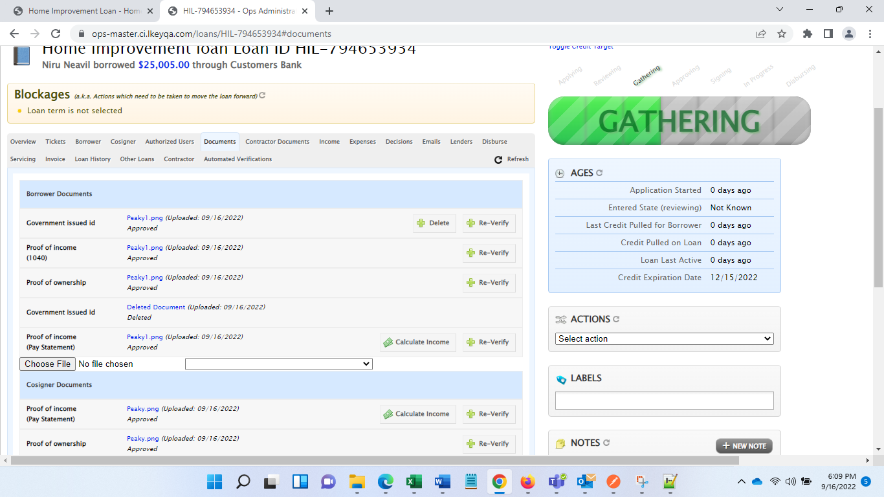

Select Loan term

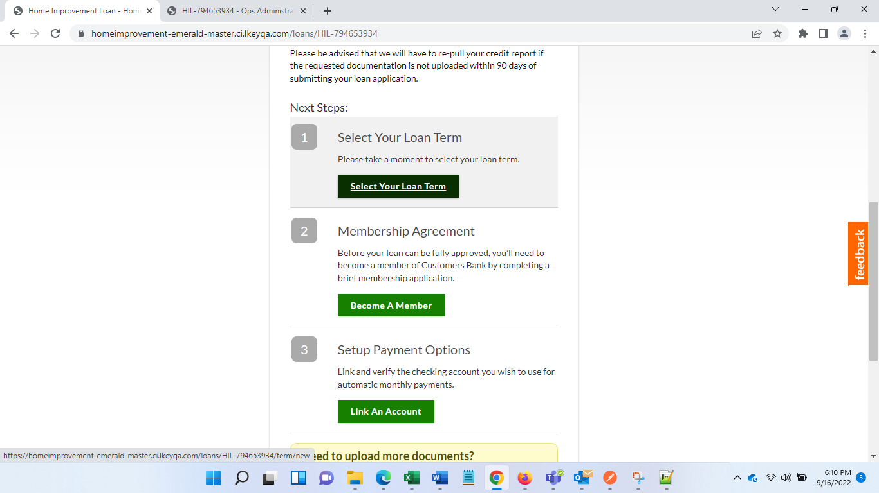 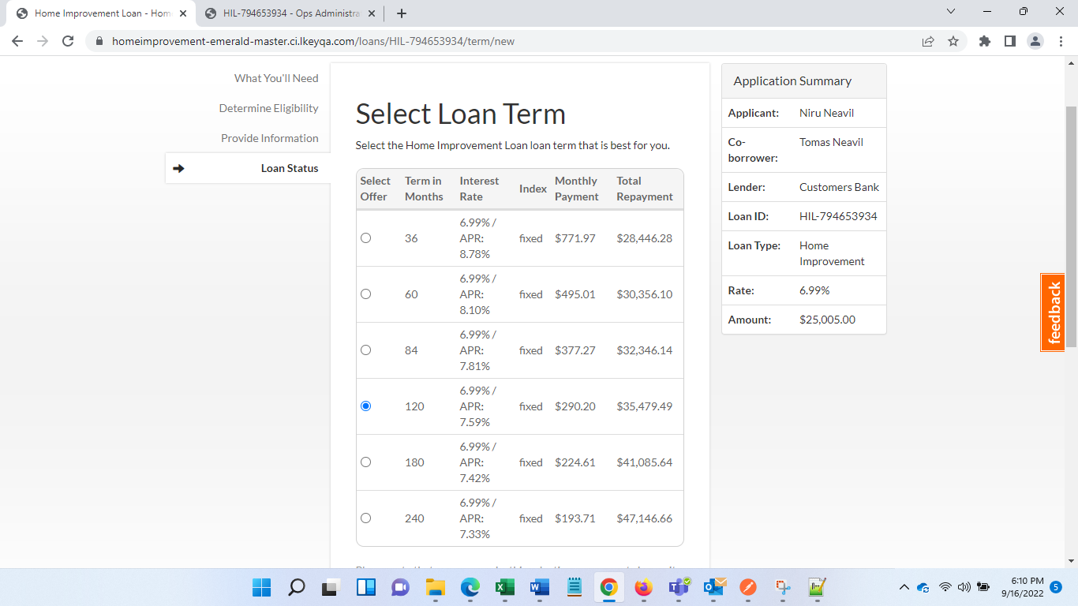 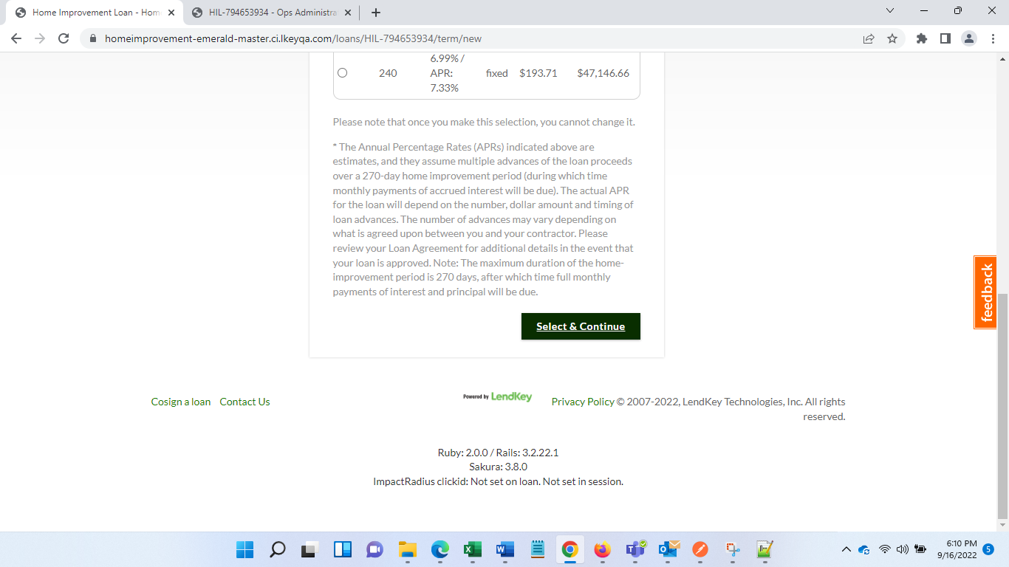 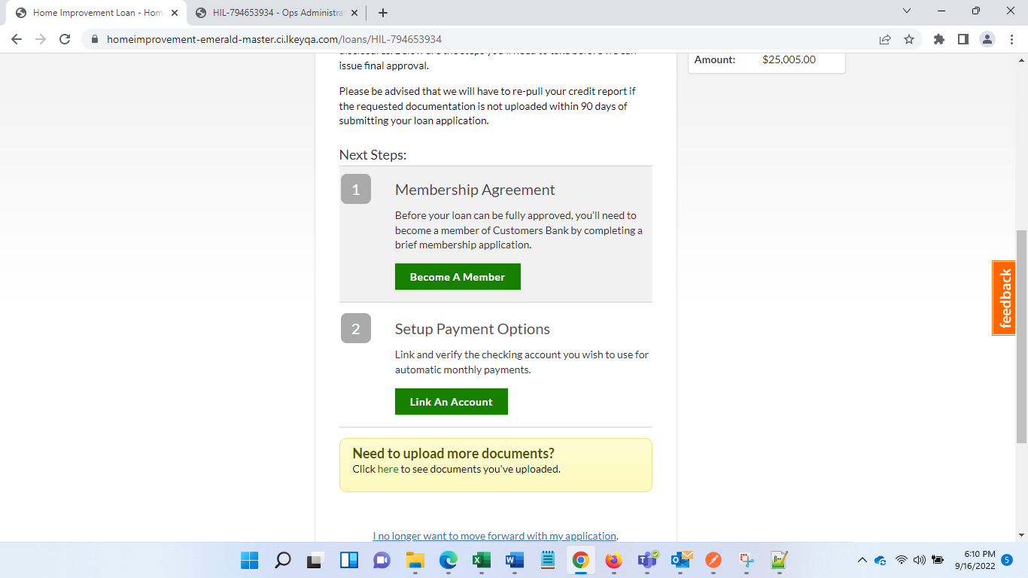

Setup membership agreement

Click Become a member

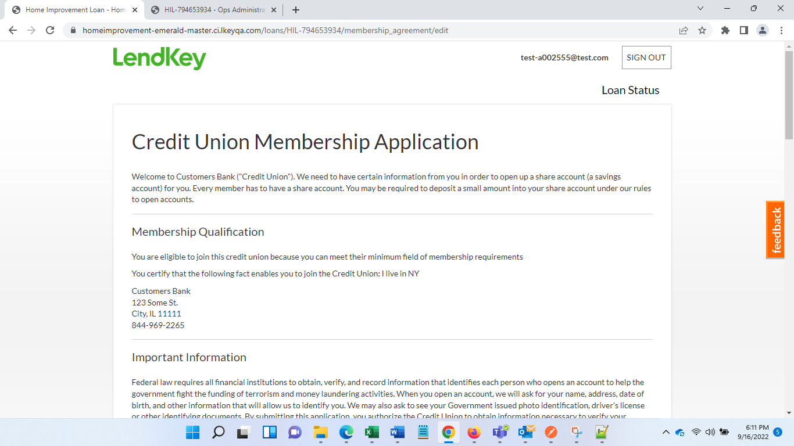 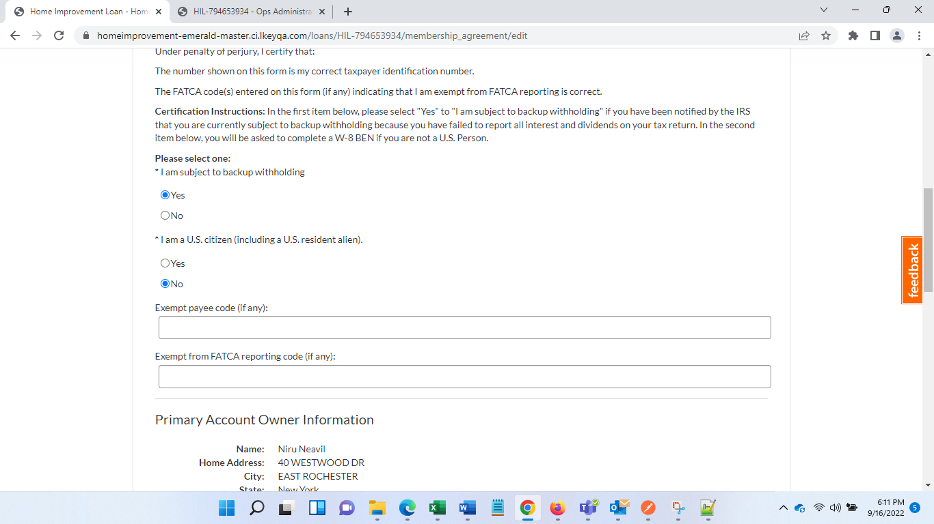 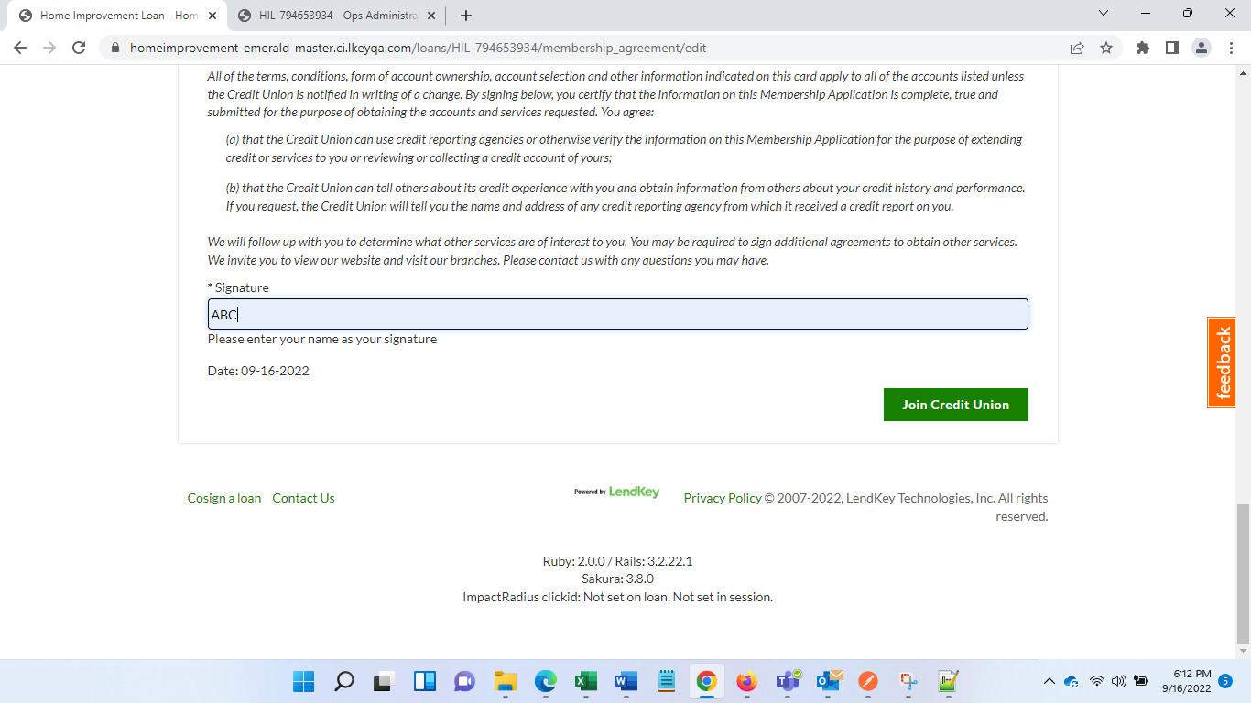 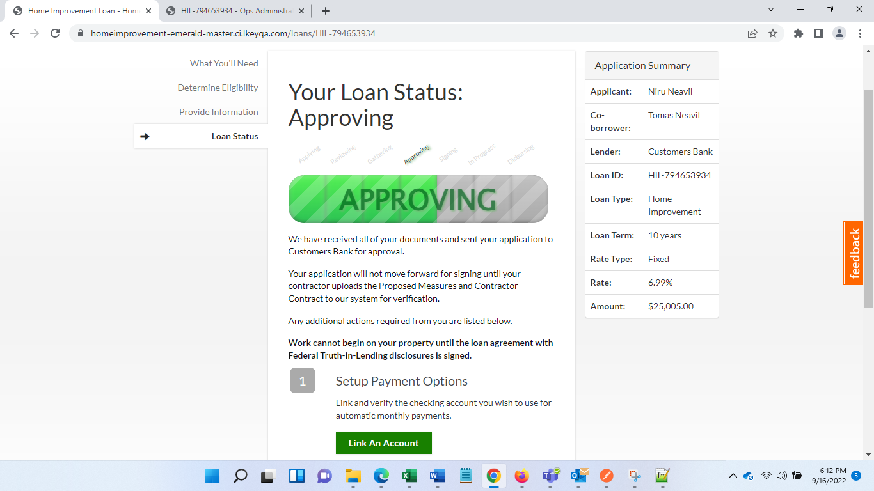

Click Link an Account and submit form

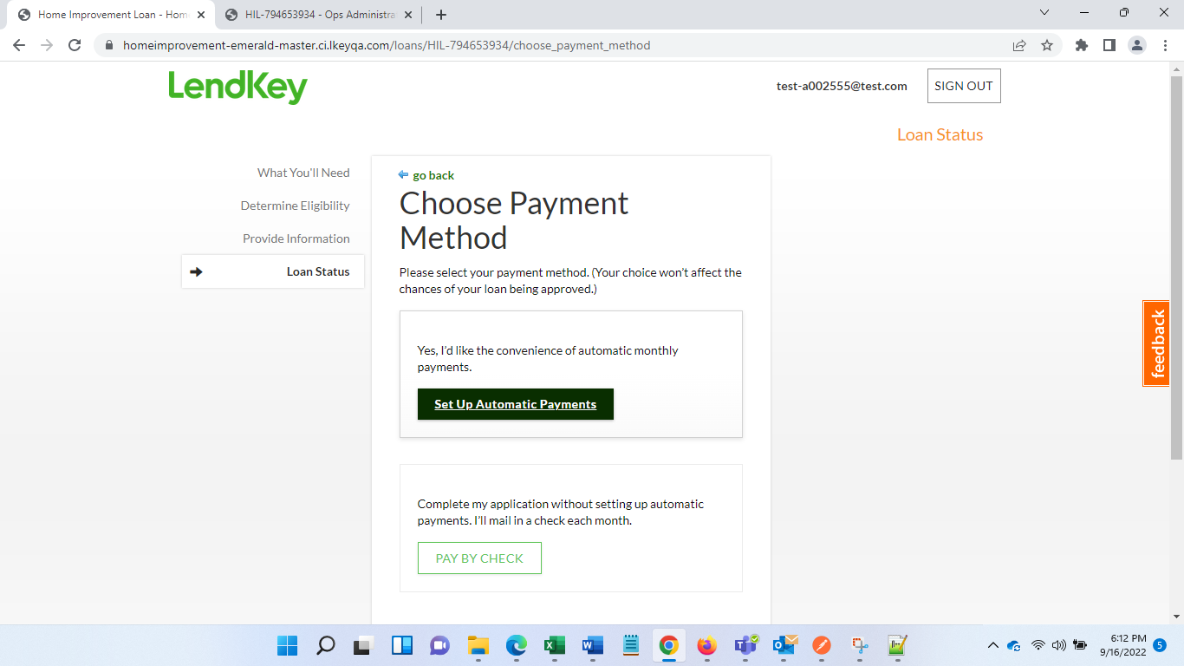 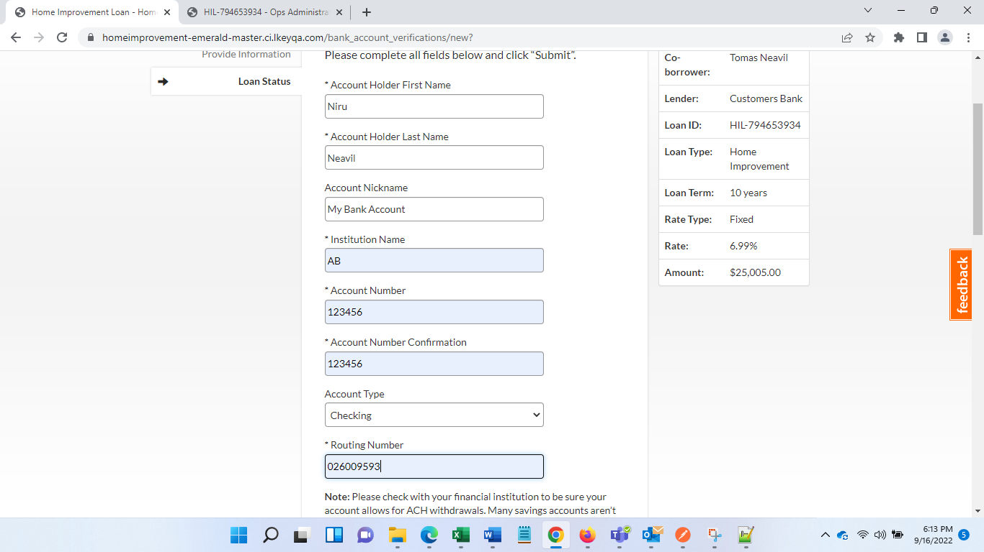 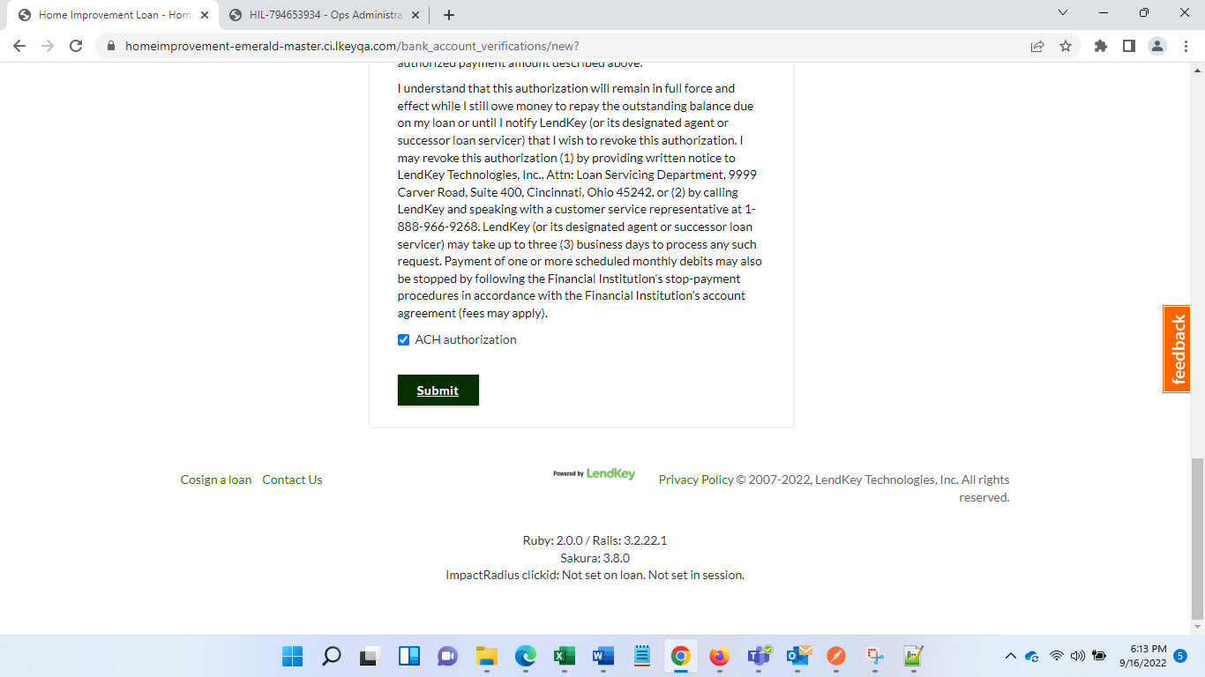

Go to Ops-admin to see blockers

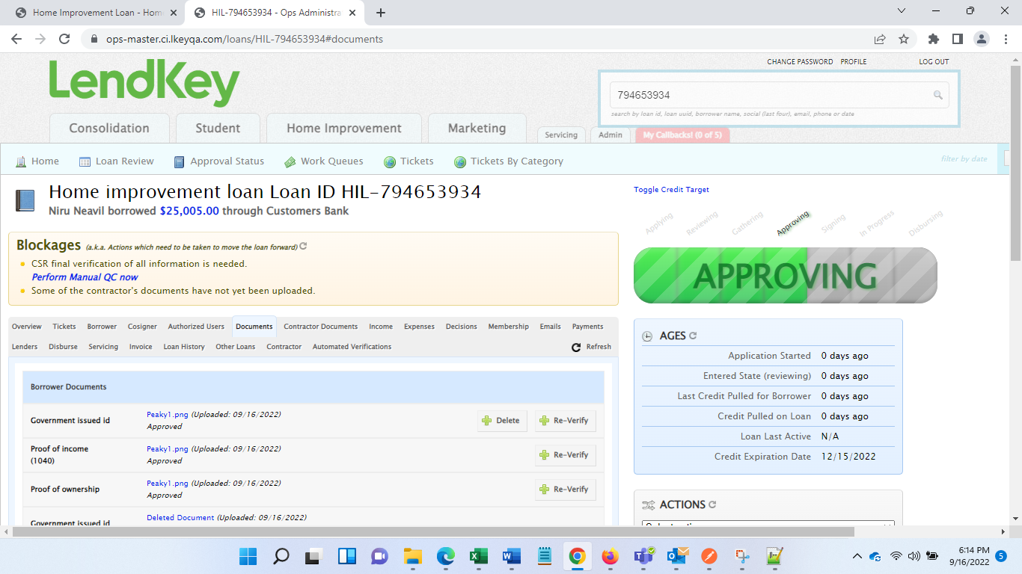

To resolve this - CSR final verification of all information is needed.

Click on hyperlink - [**Perform Manual QC now**](https://ops-master.ci.lkeyqa.com/petitions/HIL-794653934/manual_qc)

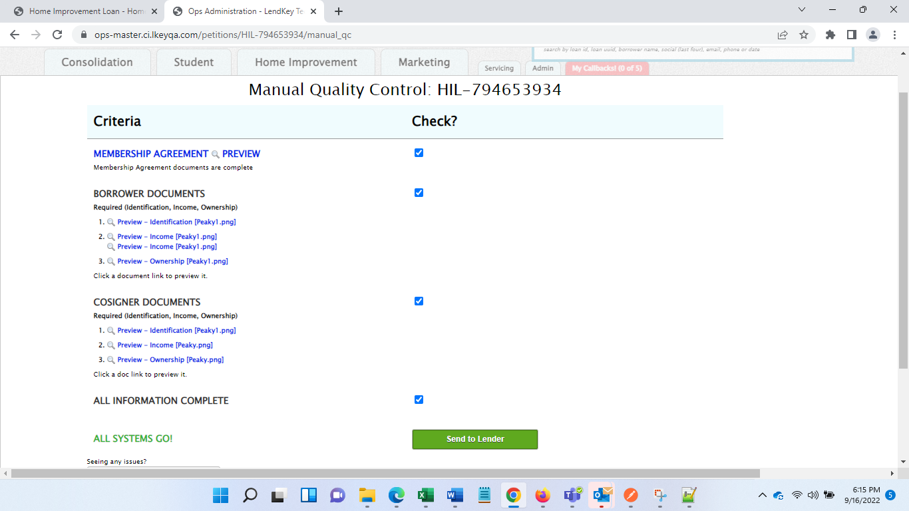

Click send to lender

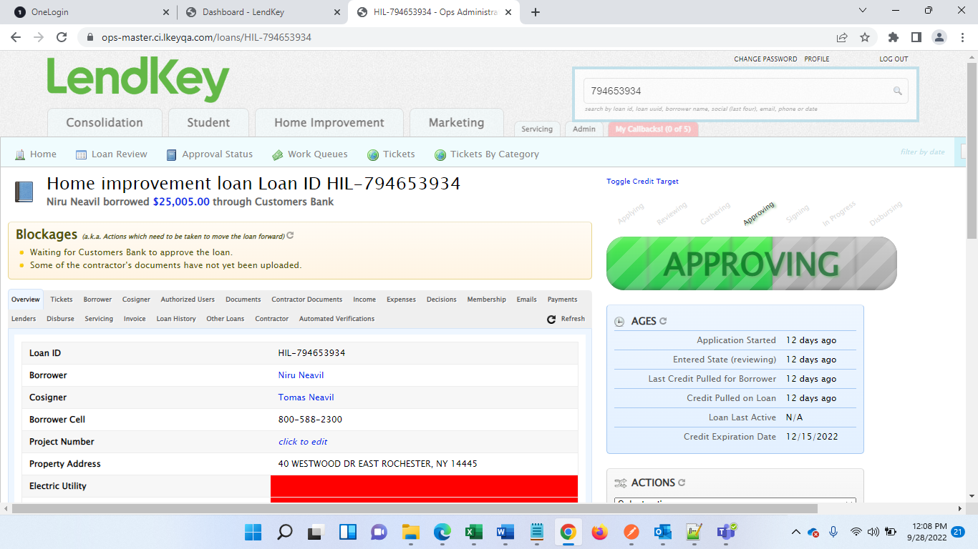

Now we must go to lenders admin page to Approve this loan

Search for Loan ID

Then from Action Tab select, Approve Loan

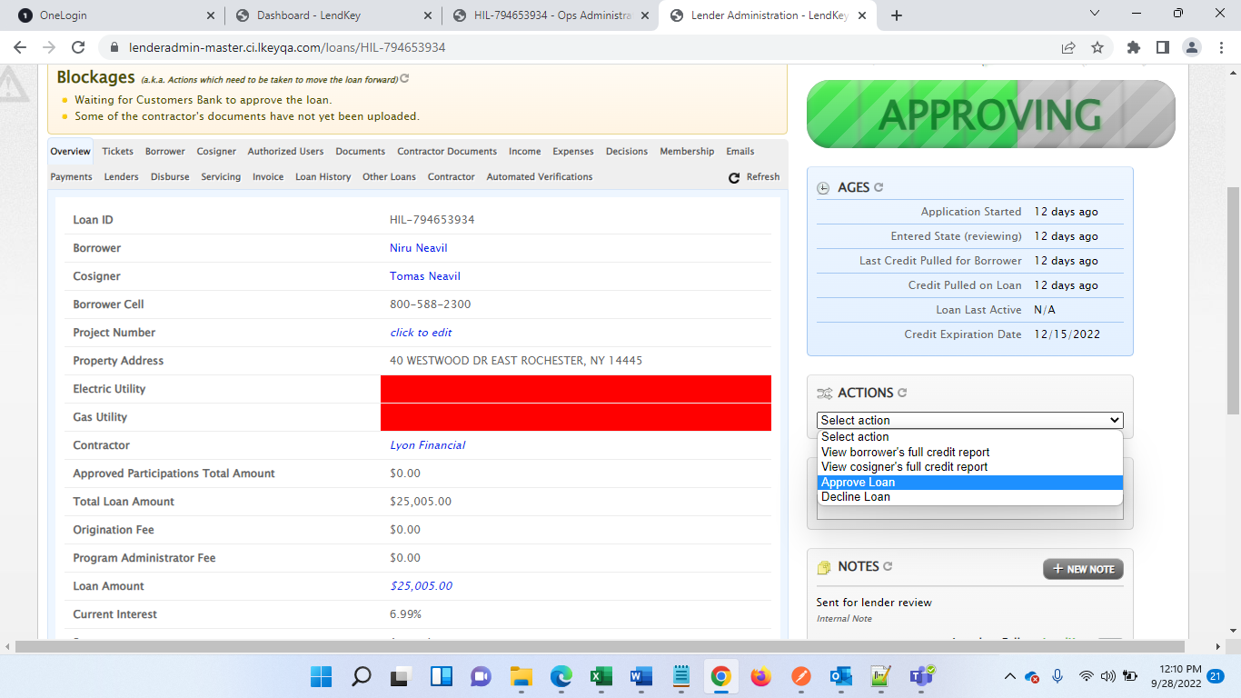

To remove error for “Some of the contractor's documents have not yet been uploaded.” Go to Contractor documents>> Upload Contractor Contract >> Verify

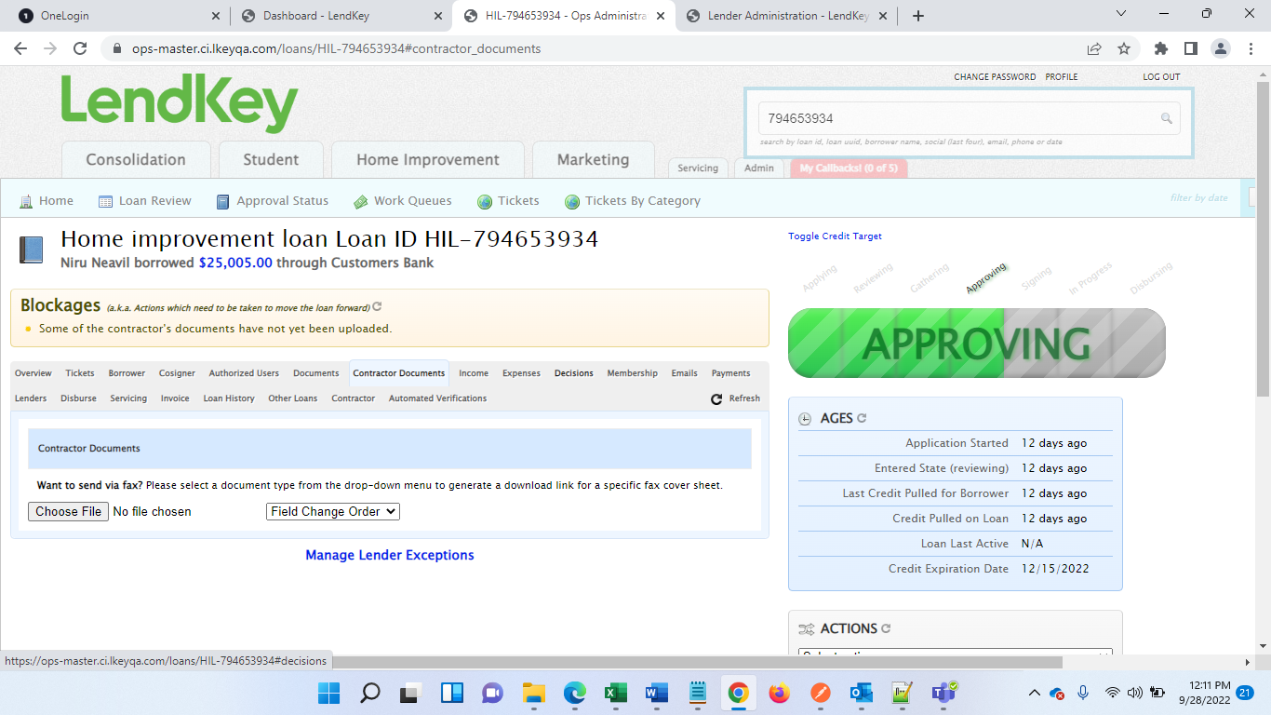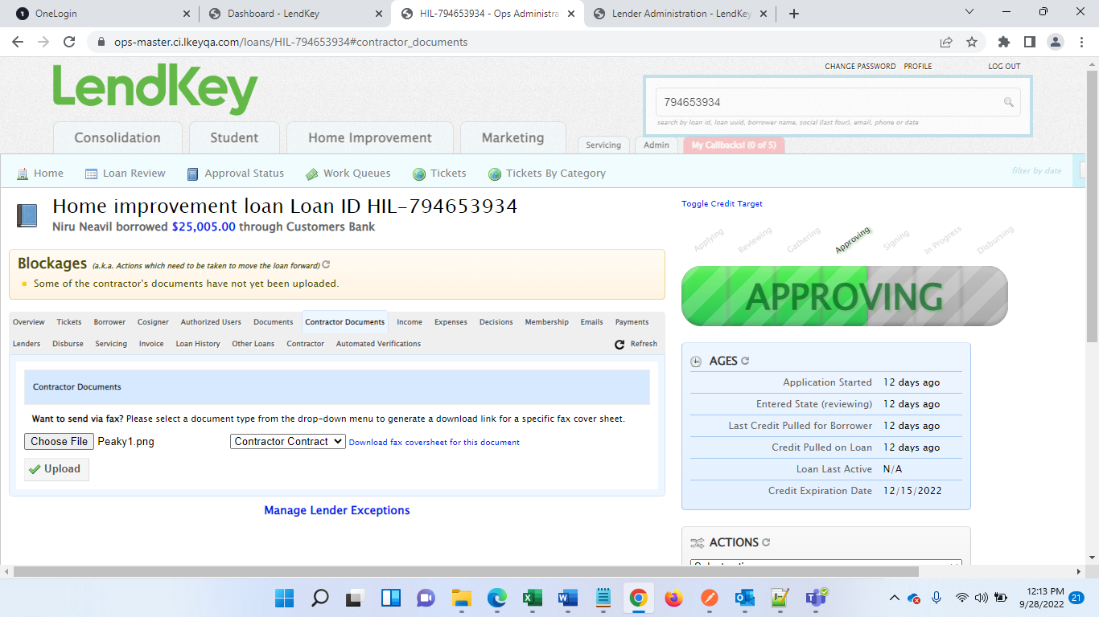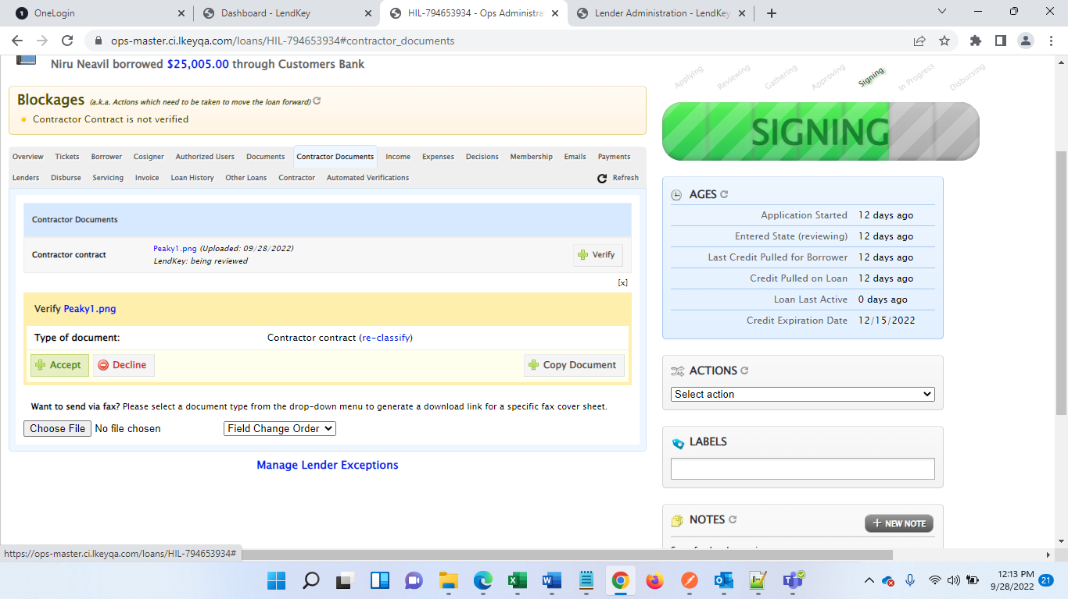

After this Status has been changed to Signing

Again see blockers

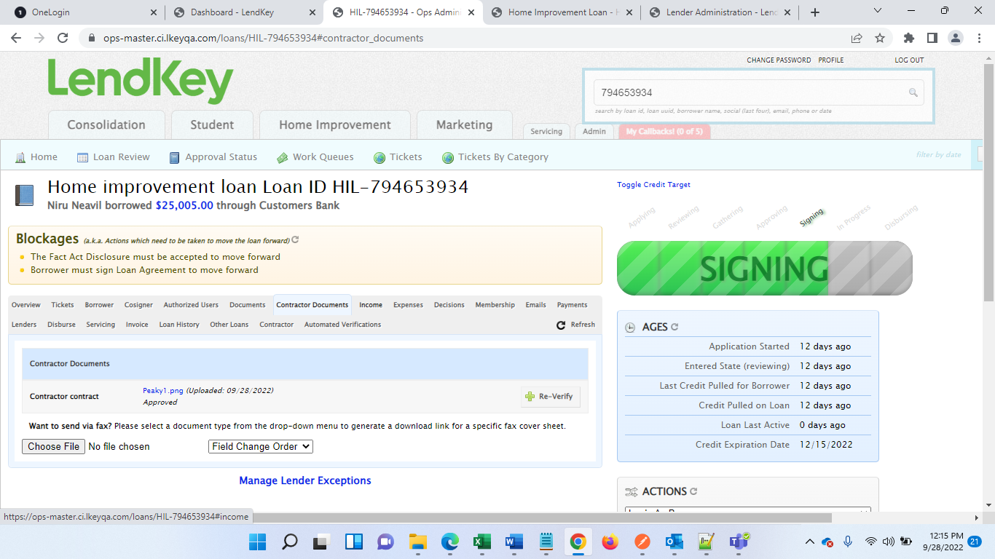

Go to Borrowers Application page and see blockers List

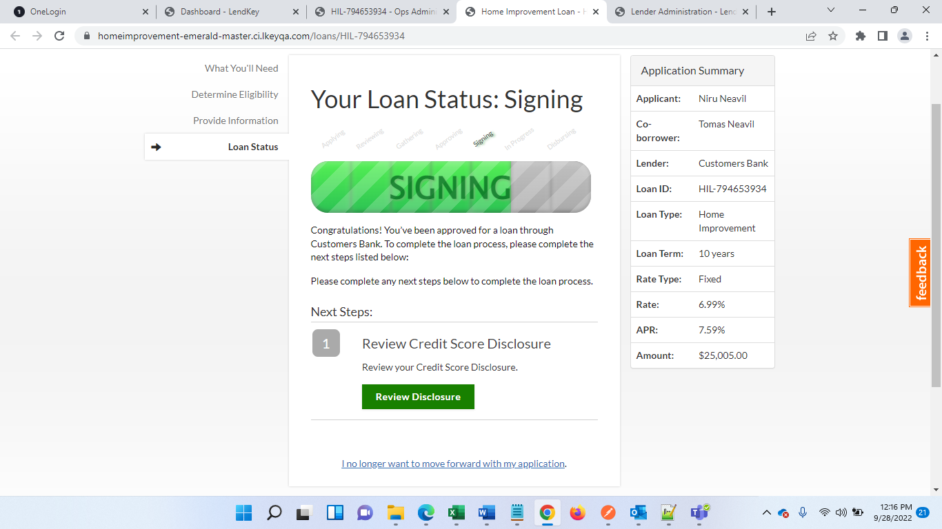

Click Review Disclosure

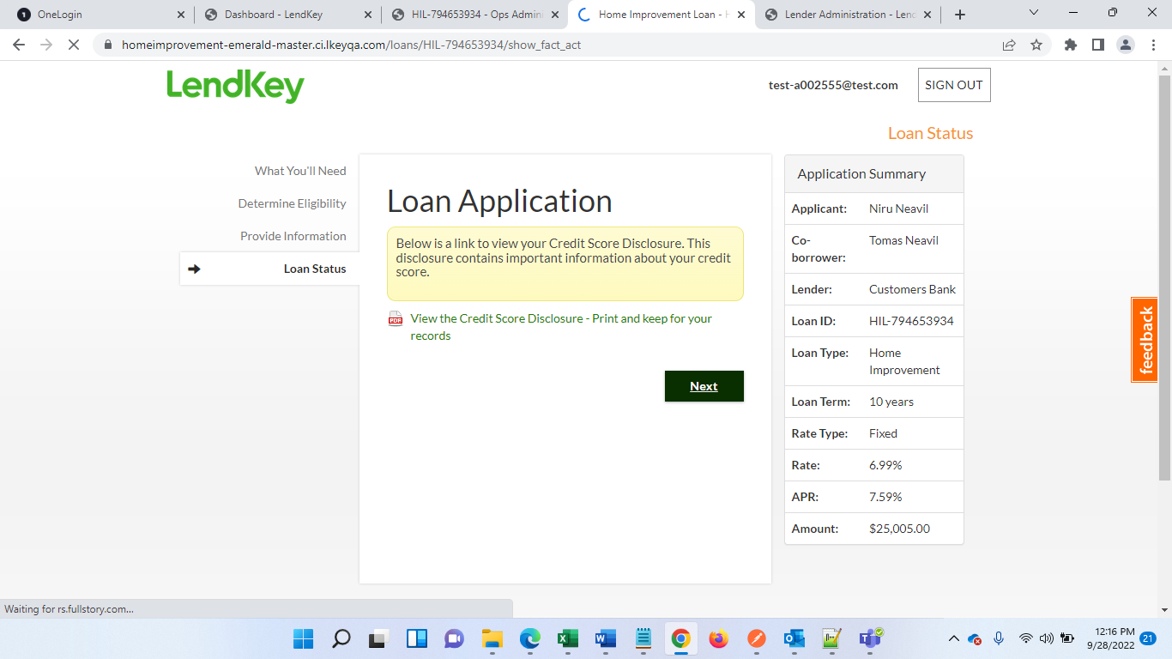

Click Next. After this error is removed

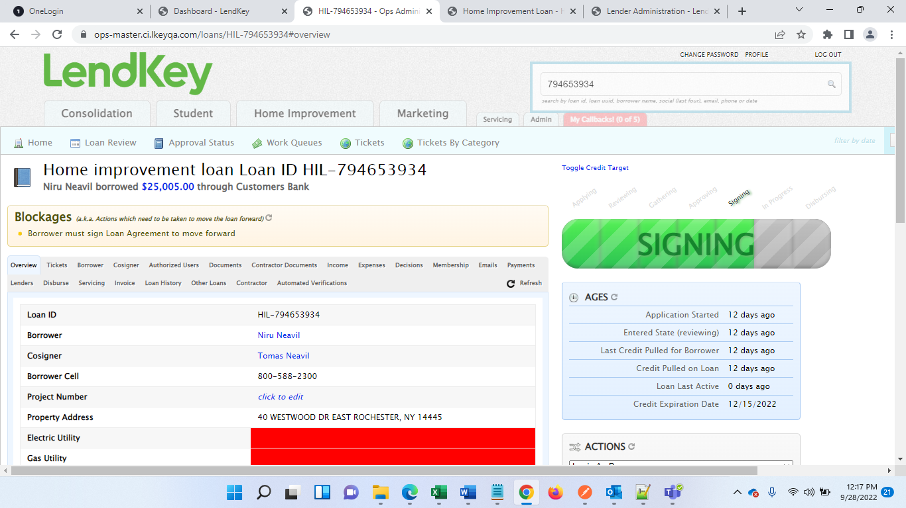

To remove above blocker, go to Borrower application and click on “Sign Loan Agreement”

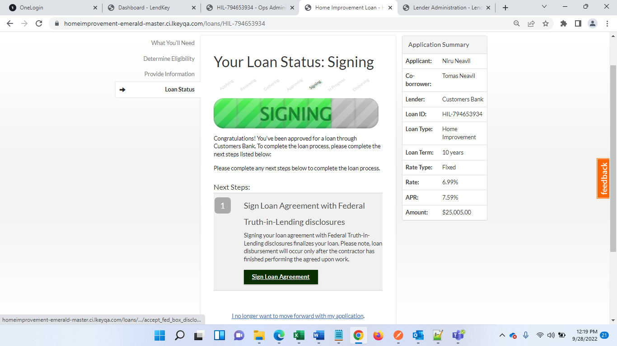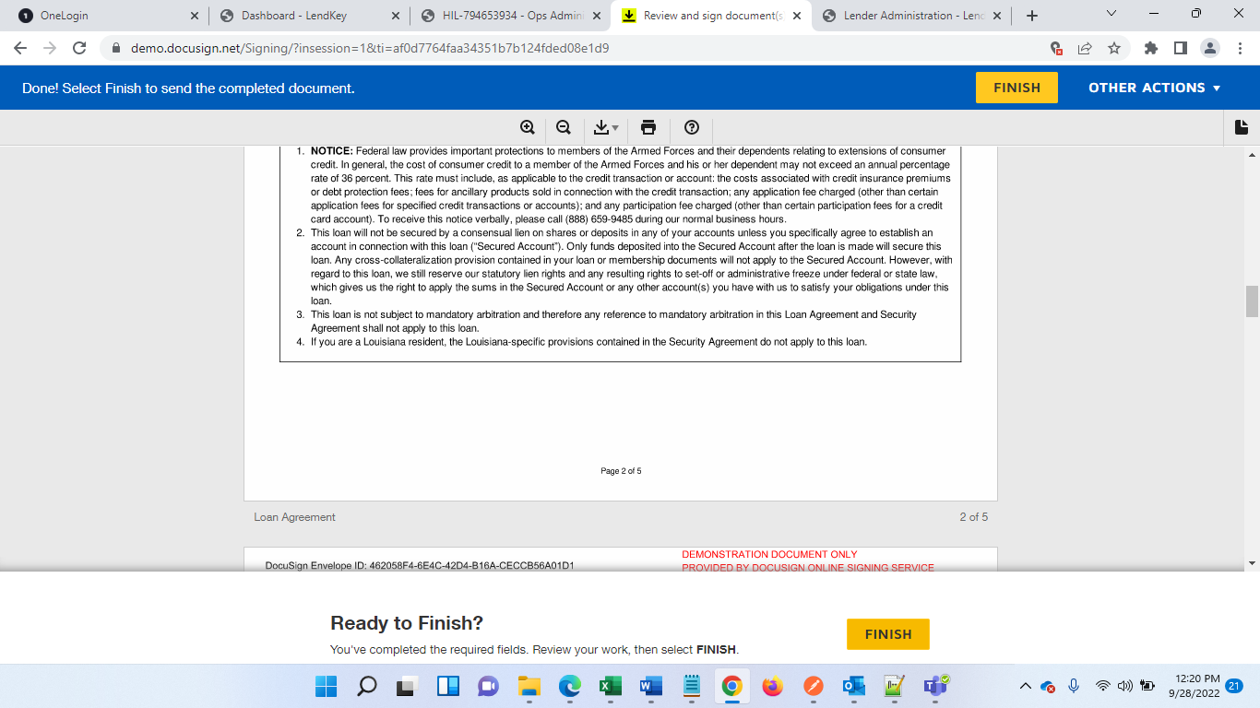

Sign Above agreement and click Finish.

Now repeat same steps to sign agreement for cosigner

Login as cosigner application

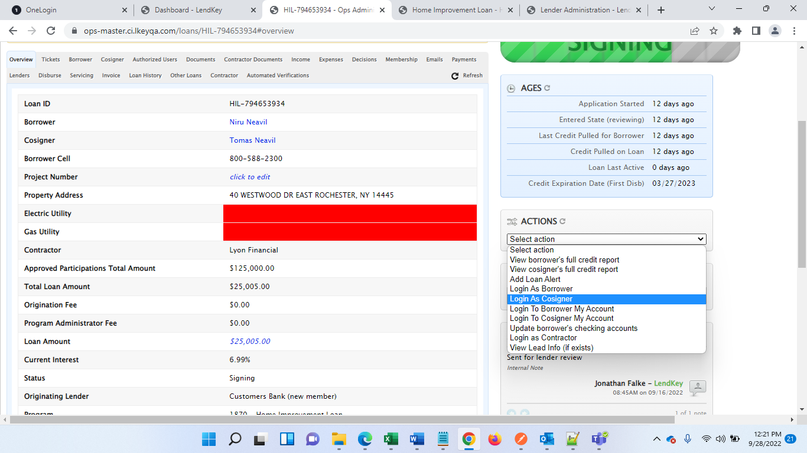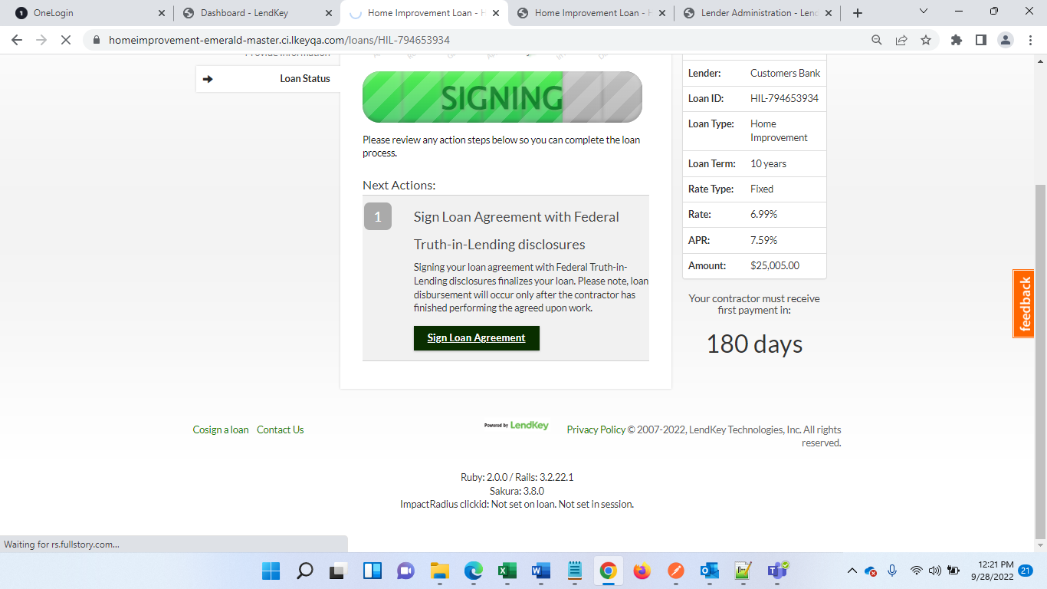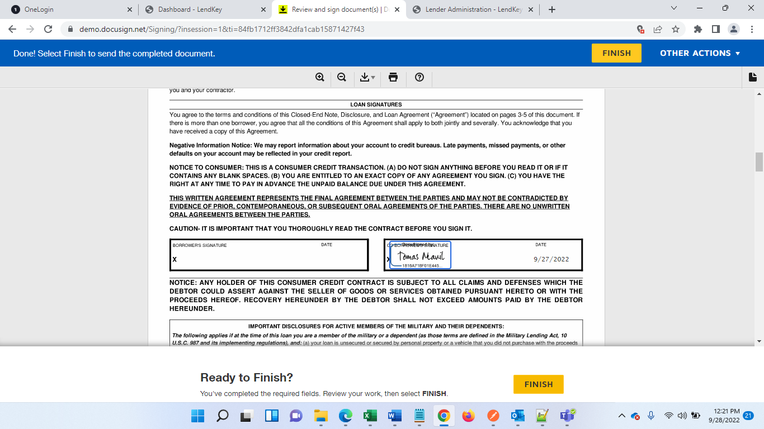

Go to Ops-admin again and see blockers

Application is now moved to In Progress stage.

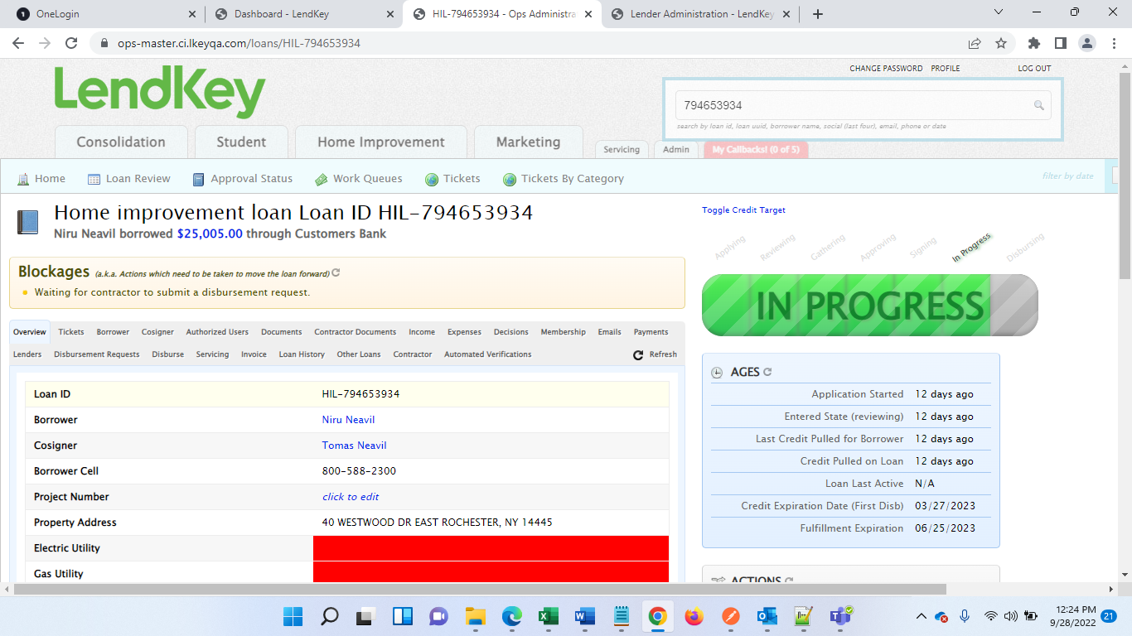

“Waiting for contractor to submit a disbursement request.” To resolve this login to contractor portal and search loan

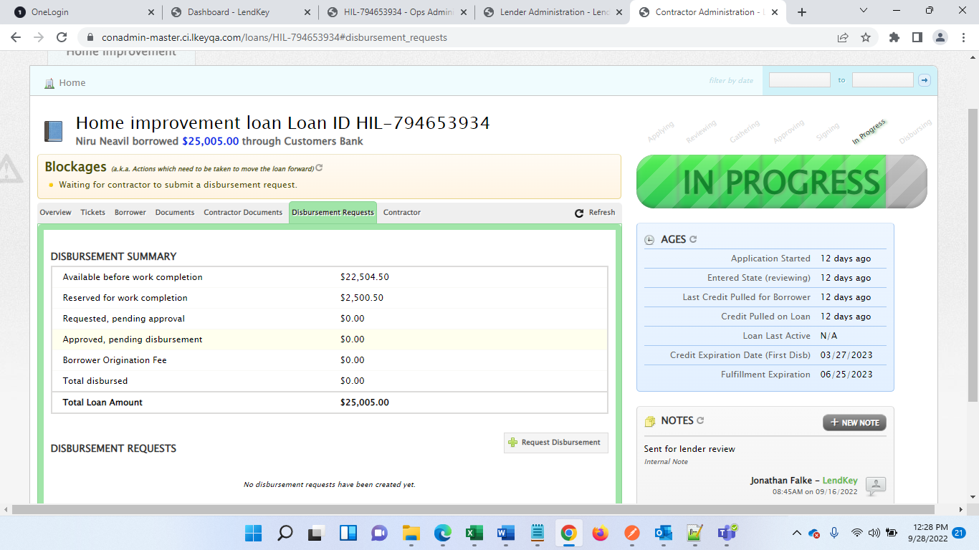

Under disbursement request, click Request Disbursement

As per your disbursement, enter values and raise request

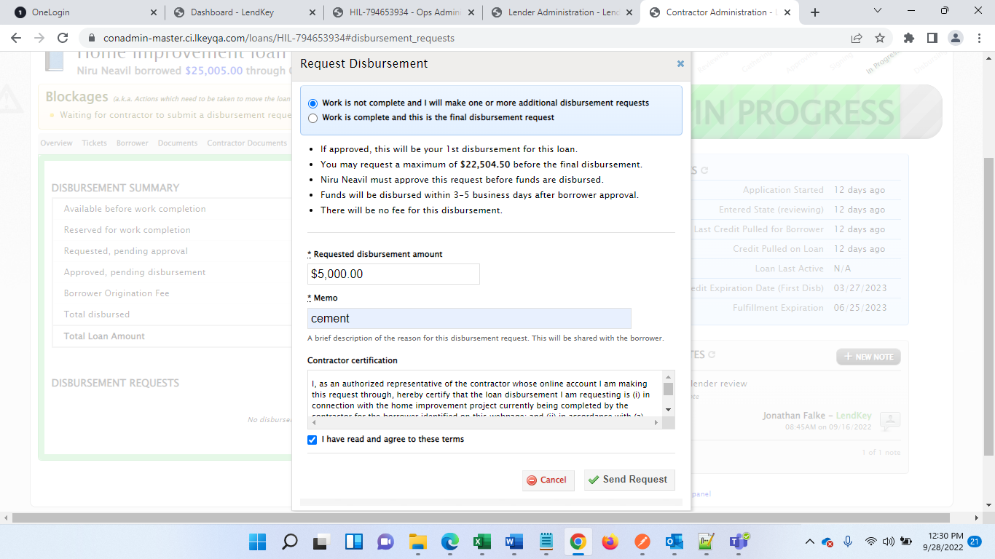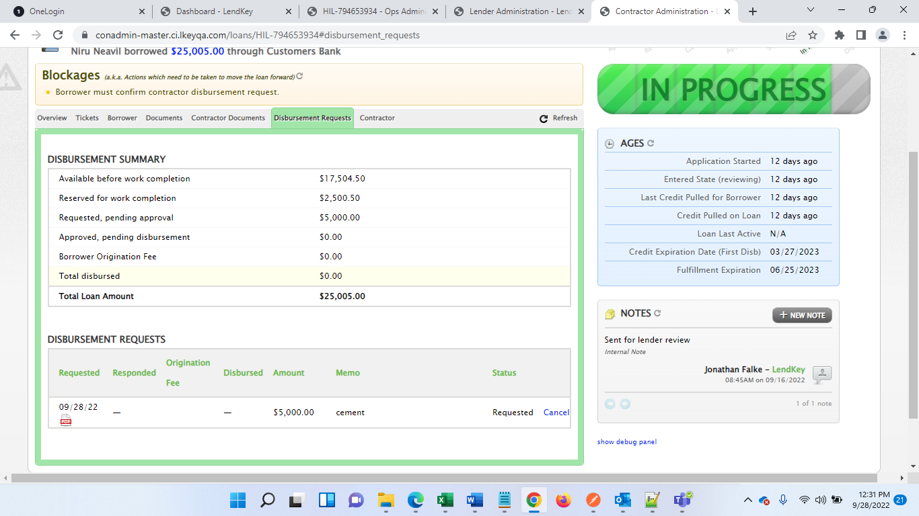

Now in Ops you will see below blocker

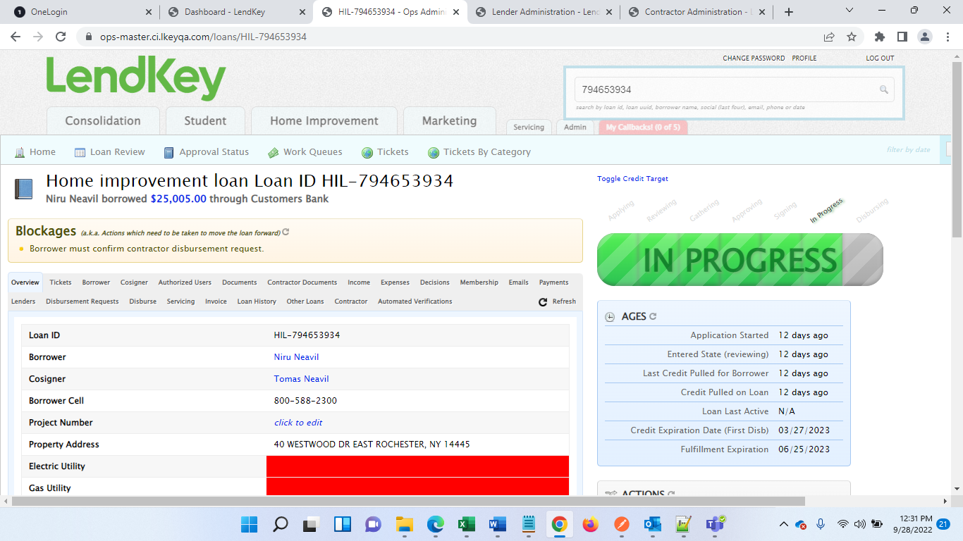

To remove this, Login with borrower from action tab,

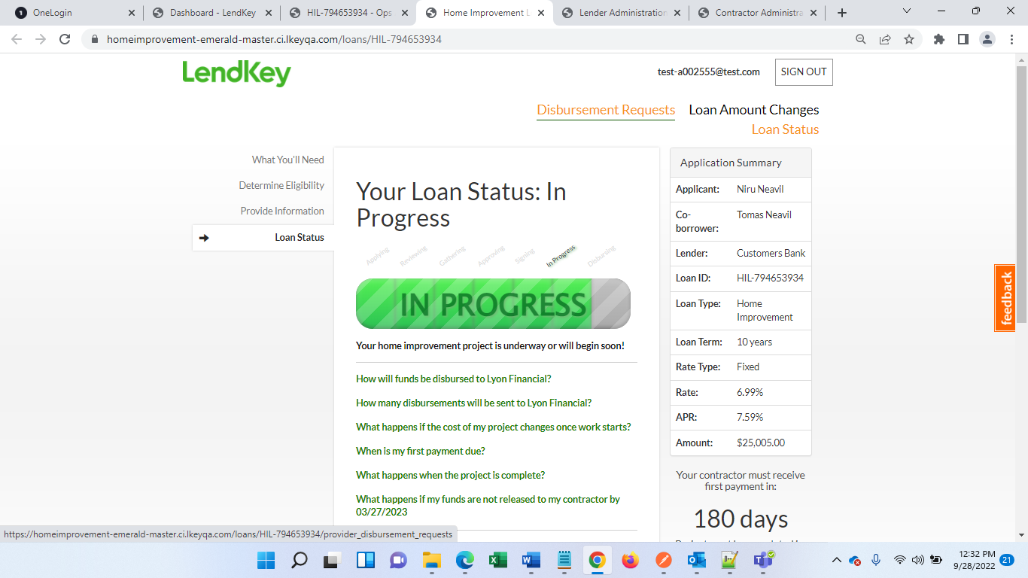

Click Disbursement request



Click Respond now

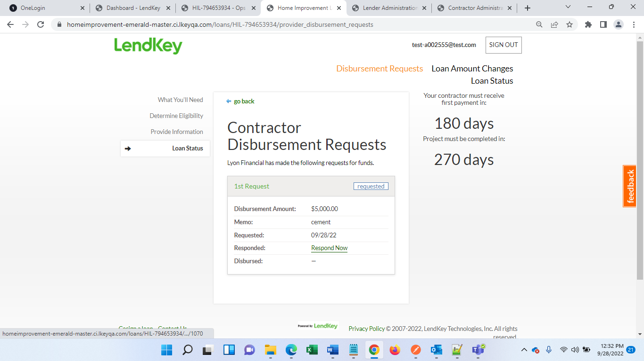

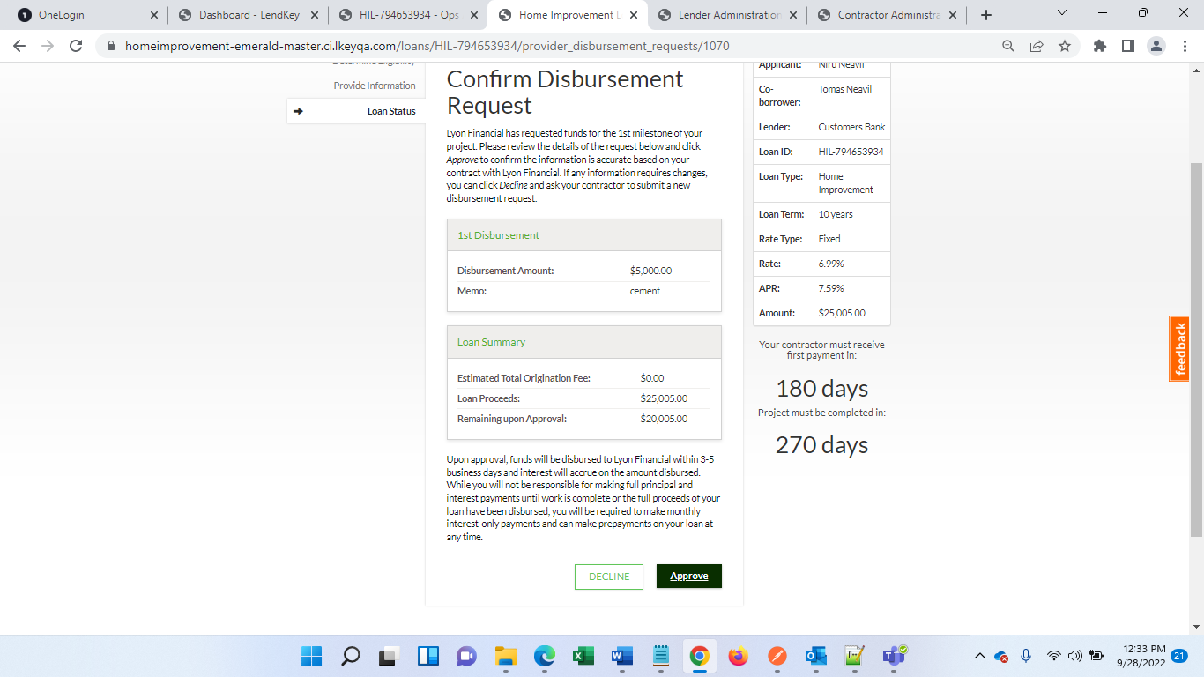Approve the request

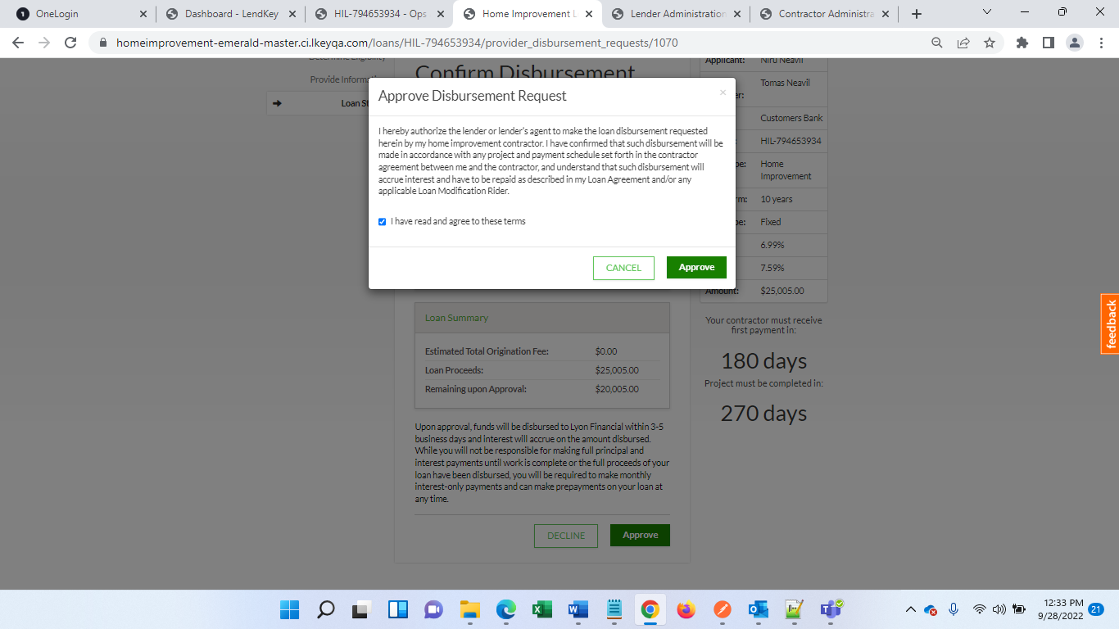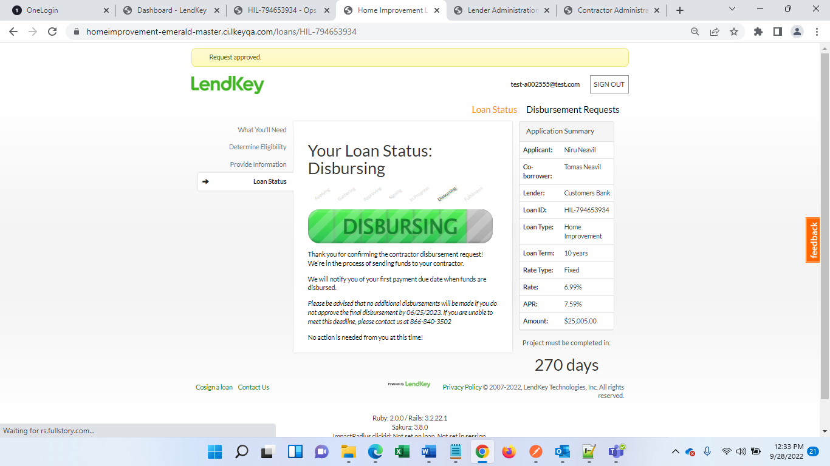

Now loan is moved to Disbursing Stage

Go to Contractor portal again to raise Final disbursement request. Remember you can raise multiple requests if you want.

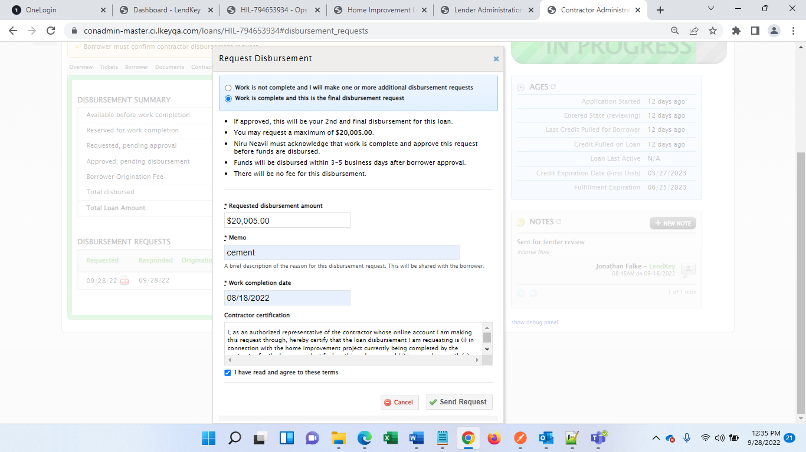

Come back to borrower login and approve final request as well

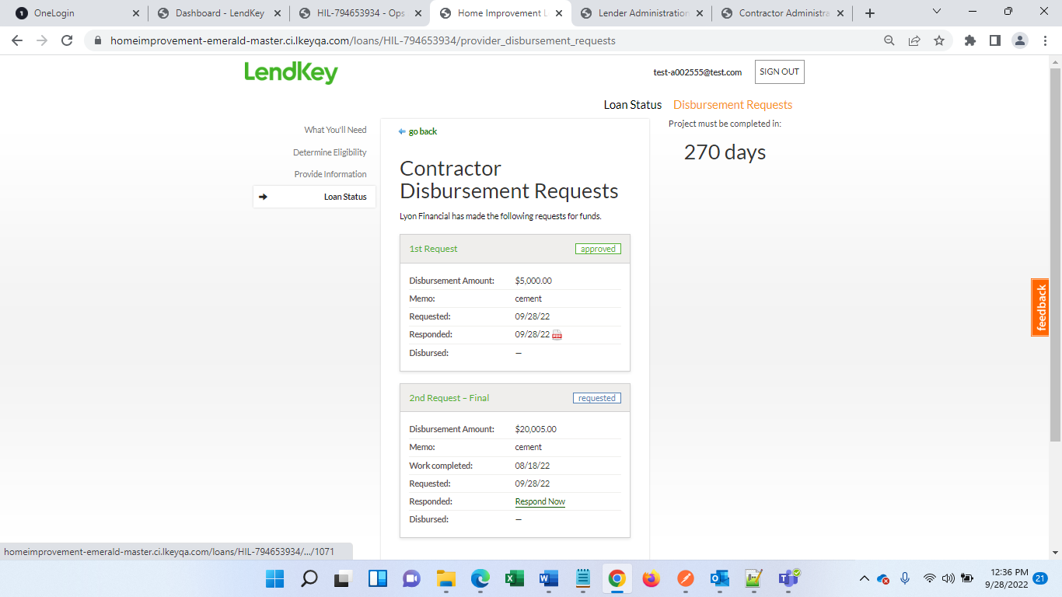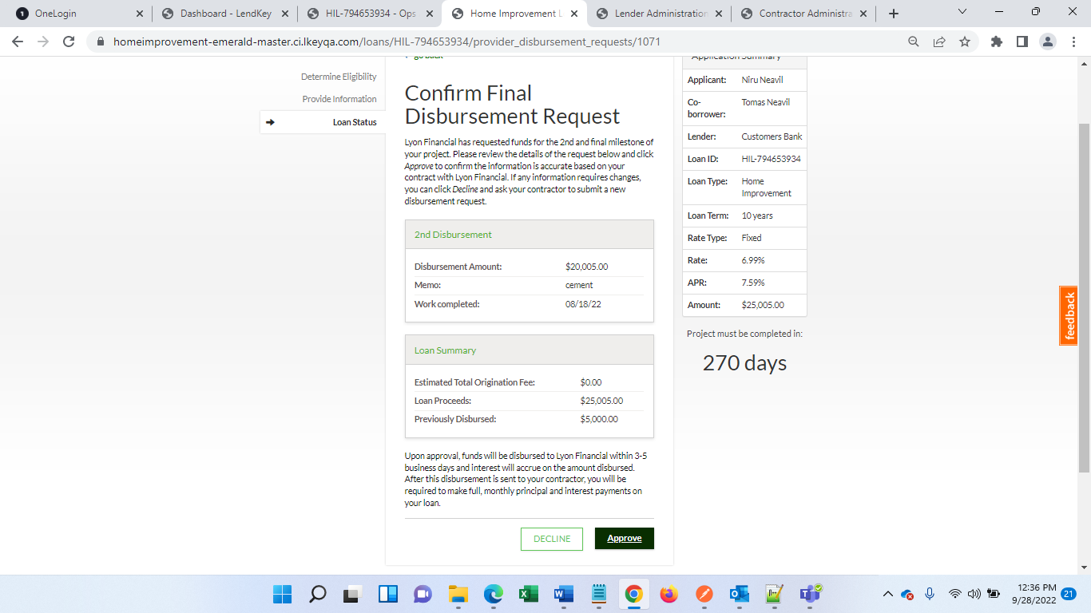

Download loan confirmation

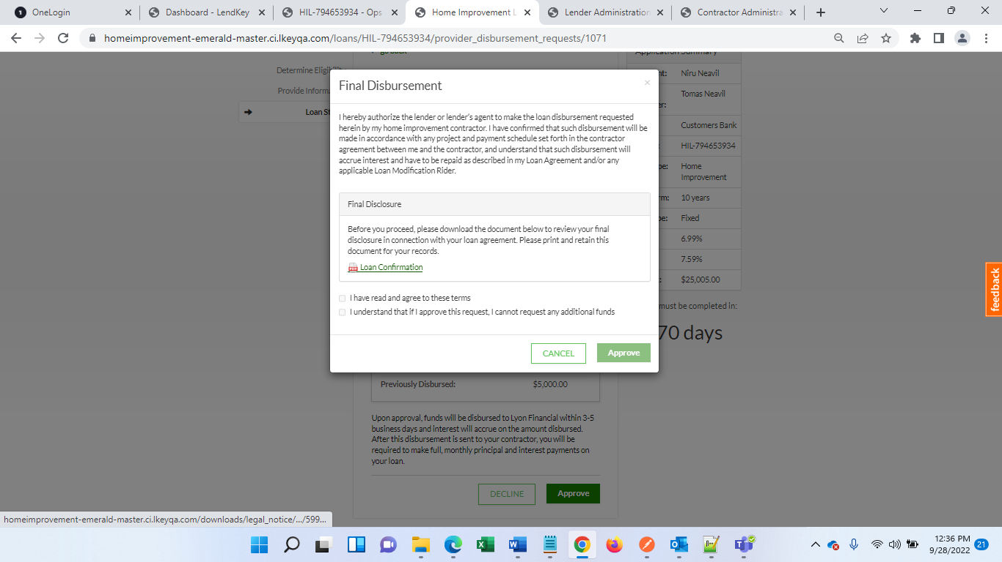

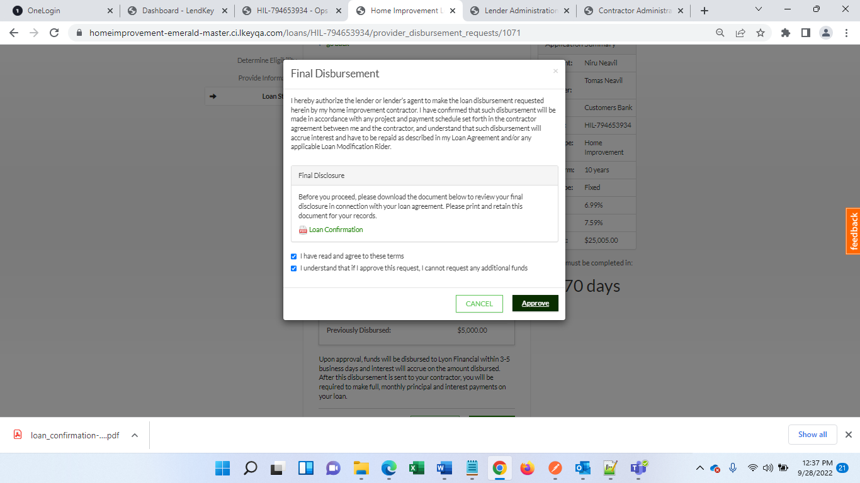

Go to Ops-admin to see rest of the blocker

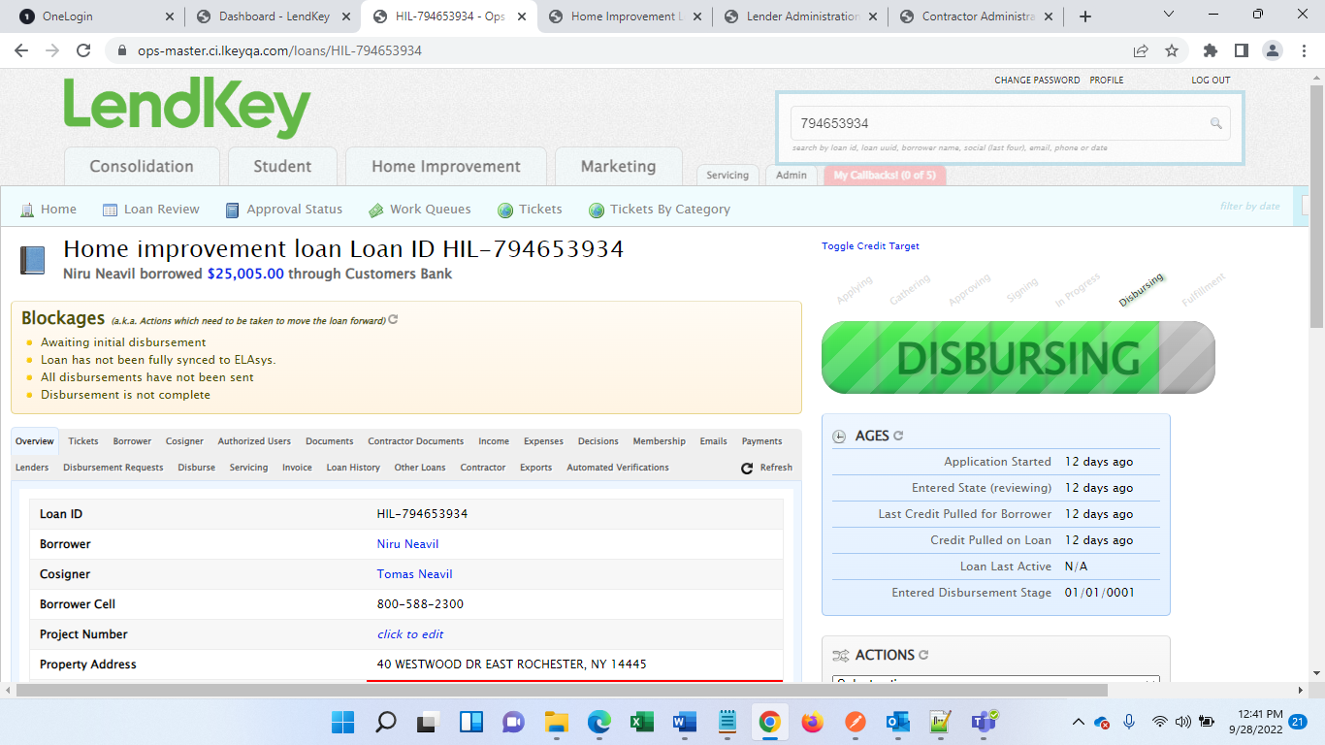

To remove above blockers, we need to run some APIs

Run below URL to participate out loan by replacing loan Key

https://api-master.ci.lkeyqa.com/qa/loans/participate/HIL-794653934

https://api-master.ci.lkeyqa.com/qa/loans/sync_to_elasys/HIL-794653934?force=1

To Get Fulfillment Status, run below URL:

https://api-master.ci.lkeyqa.com/qa/loans/create_elasys_data_for_stage/HIL-794653934?stage=fulfillment

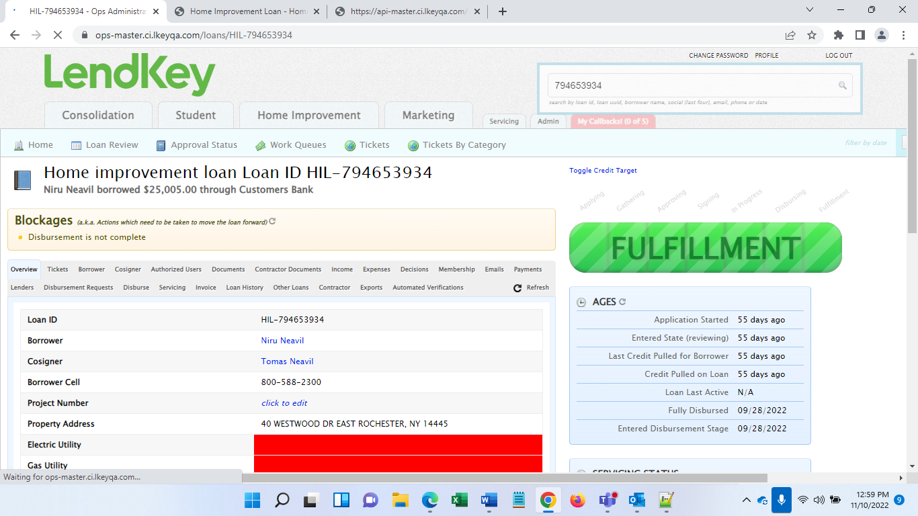

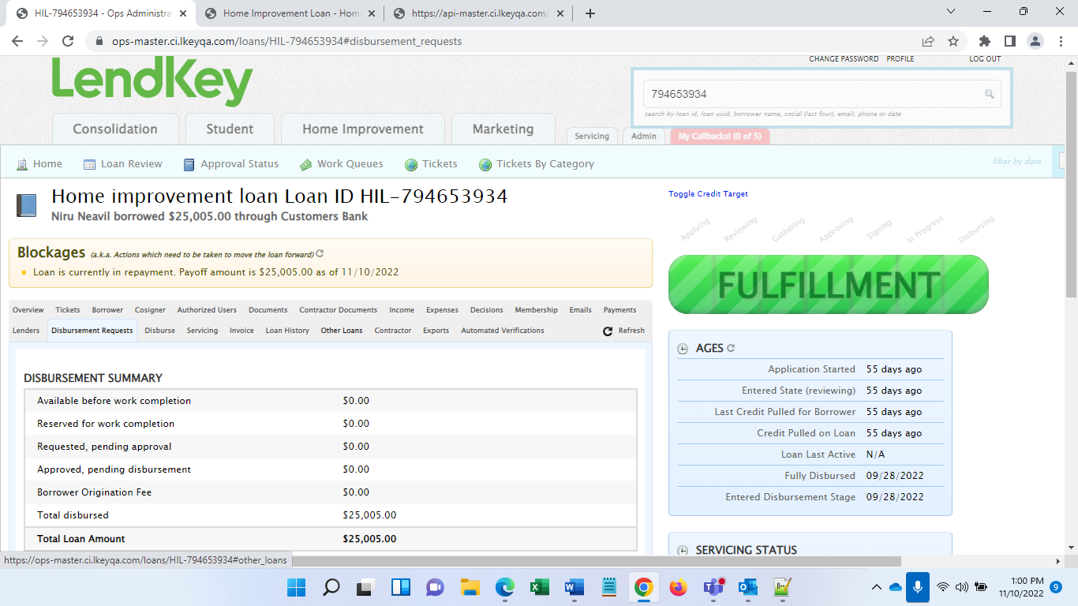

To Get Repayment Status, run below URL:

https://api-master.ci.lkeyqa.com/qa/loans/create_elasys_data_for_stage/HIL-794653934?stage=repayment

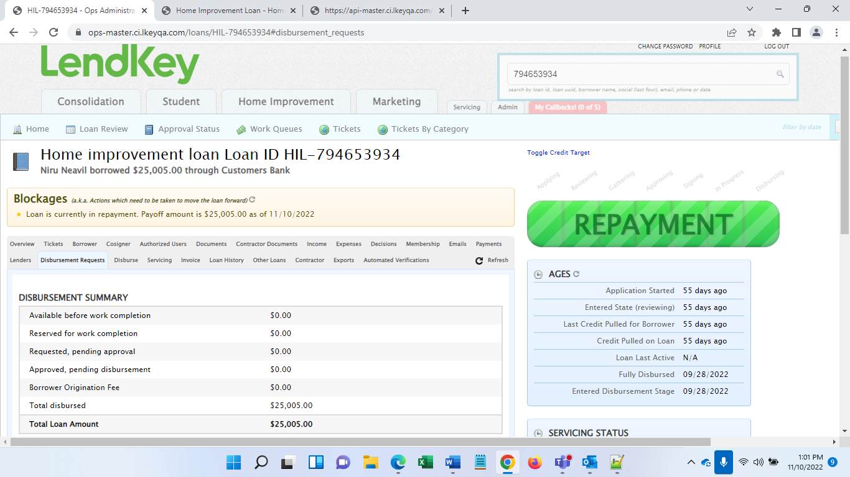

To Get paid status, send loan ID to developer (Serkan). Or login to myaccount and then take actions to get “Paid” Status.